English Composition
and Communication

Essential Understanding

Overview
This one-year course is designed for ninth and tenth grade students. It addresses the California state content standards in reading, writing, listening and speaking, and is intended to prepare students for the rigors of any four-year university English program. The thematic focus is The Individual in Society and will help you expand your vocabulary and emphasize the art of writing and speaking effectively and comprehensibly. This course will also provide you with the necessary skills and knowledge to fulfill the high school English requirement. You will develop your thinking-in-writing by practicing a variety of writing modes including description, narration, and literary analysis. You will read, discuss, analyze, interpret, debate, write and present orally on readings. Through the readings and in-class exercises, you will develop more sophisticated responses to literature, learning to create and support inferences about characters, moods, themes, etc.

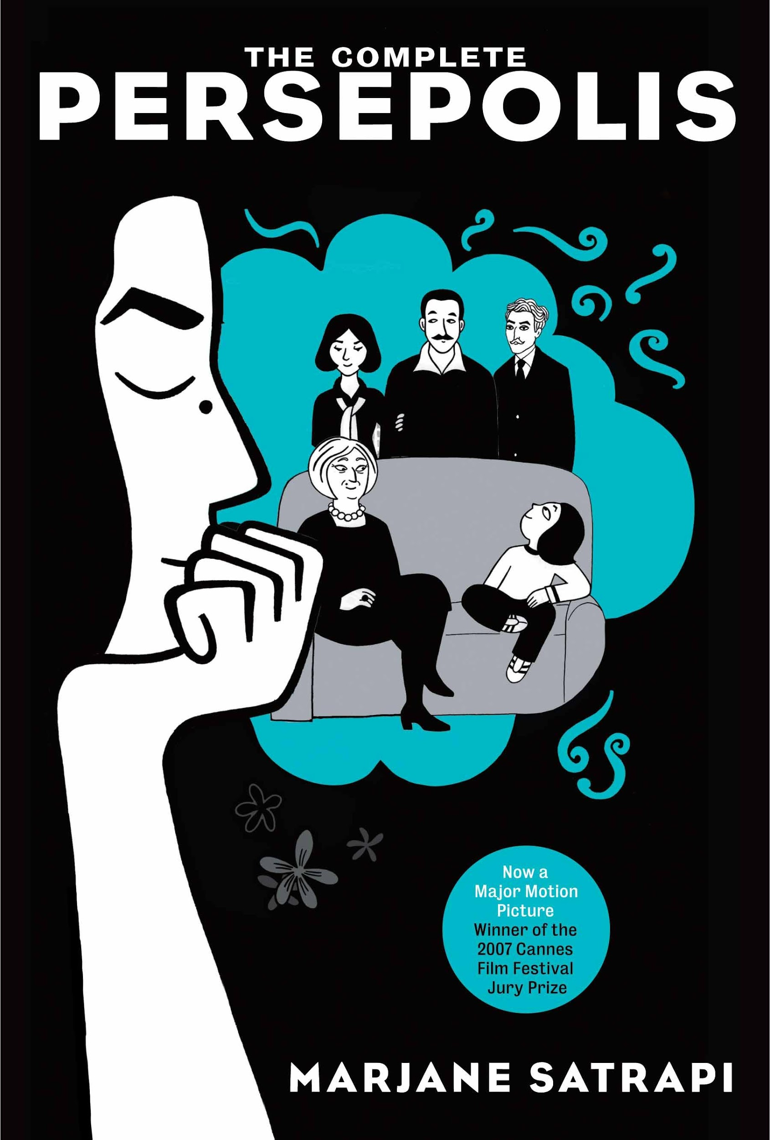
Persepolis: The Story of a Childhood
Persepolis: The Story of a Childhood is the first of two autobiographical graphic novels by Marjane "Marji" Satrapi. Writing from Paris, Satrapi recalls her childhood in Iran. The story of Marji’s childhood is set against the history of the Shah’s overthrow, the rise of the fundamentalist Islamic theocracy, and the Iran–Iraq War.

Visually, Persepolis is depicted in simple, black-and-white images. Although Satrapi states in her introduction that Iran is today associated with “fundamentalism, fanaticism, and terrorism,” the Iran of Marji’s childhood is not so simple as black and white. Indeed, six-year-old Marji is immersed in a world of complex ideas, both secular and religious. The ambitious and idealistic Marji wants to be a prophet like Zarathustra, except when she wants to be a revolutionary leader like Che Guevara. As her country becomes lost within conflict, Marji is forced to find her self.

“Life has no meaning. Each of us has meaning and we bring it to life. It is a waste to be asking the question when you are the answer.”
― Joseph Campbell
Guiding Question 1: How can our own lives be viewed in terms of a journey/quest narrative?

Lessons
____Marjane Satrapi (autobiography)
____Autobiographical Narrative vs. other forms of narrative writing
____The 12 stages of the journey/quest narrative archetype
____ Elements of an Effective Fictional Narrative
____ How to use the Journey archetype to structure a fictional narrative:
- ____Topic selection
- ____Audience
- ____Planning
- ____Drafting
- ____Revision
- ____Proofreading

Group work
_____ No class 02/19/2018

_____02/20/2018 & 2/22/2018-02/23/2018 --Hero’s Journey through Film (whole class): (using Hero’s journey graphic organizer)

_____ 03/05/2018-03/06/2018--- (Group Book Poster Project: Apply your knowledge of the Hero’s Journey to create a personalized “map” for your person. Identify the hero’s journey steps that apply. Describe the person’s QUEST and how he/she changed as a result of the journey. Failed journey? Refused the Call? Be creative in how you connect to the journey. Describe the missed opportunity

_____SAT/PSAT Write/Pair/Share: --- (after every class warm up)
- Step 1: Write (reading & answer question independently)
- Step 2: Pair (find a partner& discuss SAT/PSAT warm-up )
- Step 3: Share (whole class takeaway)

_____Read/Group/Share: (after every assigned reading)-(using read/pair/share rubric) ----
As you read the book write down on sticky notes or a separate piece of paper and then be prepared to discuss your notes with your group:

- Step 1:
- The five most important facts you learned about Marji’s, her family, or Iran.
- Three questions that popped into your head as you were reading.
- Three connections you made to Marji’s childhood.
- Step 2: Group (come together answers discussion questions)
- Step 3: Share (whole class discussion)

Individual work
Assigned “Chapter” Readings Persepolis:
___02/26/2018-02/27/2018---Ch. 1-3
___03/01/2018 -03/02/2018---Ch. 4-6
___03/05/2018-03/06/2018---Ch. 7-9
___03/08/2018-03/09/2018---Ch. 10-12
___03/19/2018-03/20/2018---Ch. 13-16
___03/22/2018-03/23/2018---Ch. 17-20

____ 03/22/2018—3/23/2018---Personal Narrative through “Mapping”

_____ Writers’ Workshop with Mr. Almanza ---- (Fictional Writing)
Your Final Assessment will be based not only on the final product, but also on showing that you completed all the steps of the writing process. These steps are:
____ 03/01/2018 -03/02/2018---Pre-write: Your DBQ graphic organizer or free write will help you generate ideas.
____ 01/25/2018-01/26/2018---Draft: The first version of your essay.
____03/08/2018-03/09/2018---Revise: Fix the organization, ideas and provide proof
____03/22/2018-03/23/2018---Edit: Correct spelling, punctuation and grammar
____03/29/2018-03/30/2018---- Publish: Turn it in for me to grade it
____________________________________________________________________________

_____ Class Warm-ups: Responses to class SAT/PSAT Questions (beginning of every class)

_____Achieve 3000: After SAT/PSAT Write/Pair/Share (Annotating articles using various readings from Achieve 3000) ------ should be completing one activity weekly.

_____02/21/2018-02/22/2018 ---Define vocabulary: (Using Vocabulary Knowledge Rating Handout Checklists)

Archetype
Audience
Body language
Character/Characterization
Climax
Conflict
Dialogue
Flashback
Genre
Juxtaposition
Metaphor
Narration
Pacing
Point of View
Satire Theme

_____ 02/26/2018/-02/27/2018 ---Persuasive Essay (at least, 750 words) What qualities do you think make a hero?

Essay Rubric

Grading Criteria | Exceeds  Mastery  (A range) | Mastery  (B range) | Approaching  Mastery  (C range) | Below Mastery  (D) | Resubmit  (F)
Structure: essay has an introduction (with thesis statement), 3 body paragraphs & strong conclusion
Content: Student has a clear claim or argument with specific, but varied examples
Evidence: Student has used quotes, examples and evidence to support thesis and claims.
Mechanics: Student enforces proper grammar, spelling, sentence structure and evidence of editing.
Overall:

_____ Socratic Seminars: ---- (using specific words/phrases from “Persepolis”)
___03/01/2018 -03/02/2018-- Socratic Seminar 1
___03/08/2018-03/09/2018-- Socratic Seminar 2
___03/22/2018-03/232018 -- Socratic Seminar 3

______ Preparing questions for and participating in a Socratic seminar (using “Persepolis”)

Socratic Rubric
 | Preparedness | Participation | Synthesis/Takeaway | Self-Evaluation
Description  *overarching theme of treating all contributions & classmates with respect & dignity | -Has carefully read & annotated article  -Brings article/notes to the Seminar  -Higher level questions are prepared & ready to share | -Refers to article & provides evidence to support opinion  -Uses complete sentences &  content-specific vocabulary  -Builds on others’ contributions by restating & paraphrasing | -Connects Socratic Seminar topic to class content/ lessons  -Shares final thoughts using evidence from the article or a specific response to what a classmate shared | Exit Slip (class take away)  -Includes thoughtful goals for next time  -Turned in to the teacher before exiting classroom
Points | /5 | /5 | /10 | /10
Total:
/30

____________________________________________________________________________
____ Quick Writes (class take away) --- (at the end of every class)

Assessment
_____ 03/29/2018-03/30/2018---Assessment 1: We are all on “quest narratives” of our own in this life, each in our own way. Write a personal narrative piece about your own life (so far), or one specific ‘big event’ in your life so far, and incorporate the various elements that we have studied in class. Your essay should have a strong beginning, middle, and end and generally follow the format of the Hero’s Journey.
(Hint: Think about how you can write out your life map into a personal essay.) 3-4 pages, typed, double spaced, standard margins, 12 point font, MLA format.

Extensions
____03/29/2018-03/30/2018---STORYTELLING: Create, develop, outline, and tell a “hero’s journey” original story.

Readings
Persepolis by Marjane Satrapi

Addendum: Detailed Class Policy

Expectations:
• Respect the classroom, others and yourself. Model GRACE and COURTESY.
• Be on time, prepared and in your designated seat at the start of class.
• Raise your hand and wait to be called on before talking.
• Listen attentively to others respectfully.
• No Candy, Drinks (with the exception of sealed container) or Gum is allowed.
• Electronics must be used appropriately and wisely.
-------NO CELL PHONES IN CLASS.
-------No Headphones (Ask Teacher)

PAGE 4 OF 9

CHRISTINE DAISY H

