Spanish 2
--------------------------------------------------------------------------------------------------------------------------------------------------------

Essential understanding: Now that you have basic knowledge of Spanish greetings, numbers, alphabet and culture; you will begin to “sew” together all the pieces to create your own understating and practice of the language.

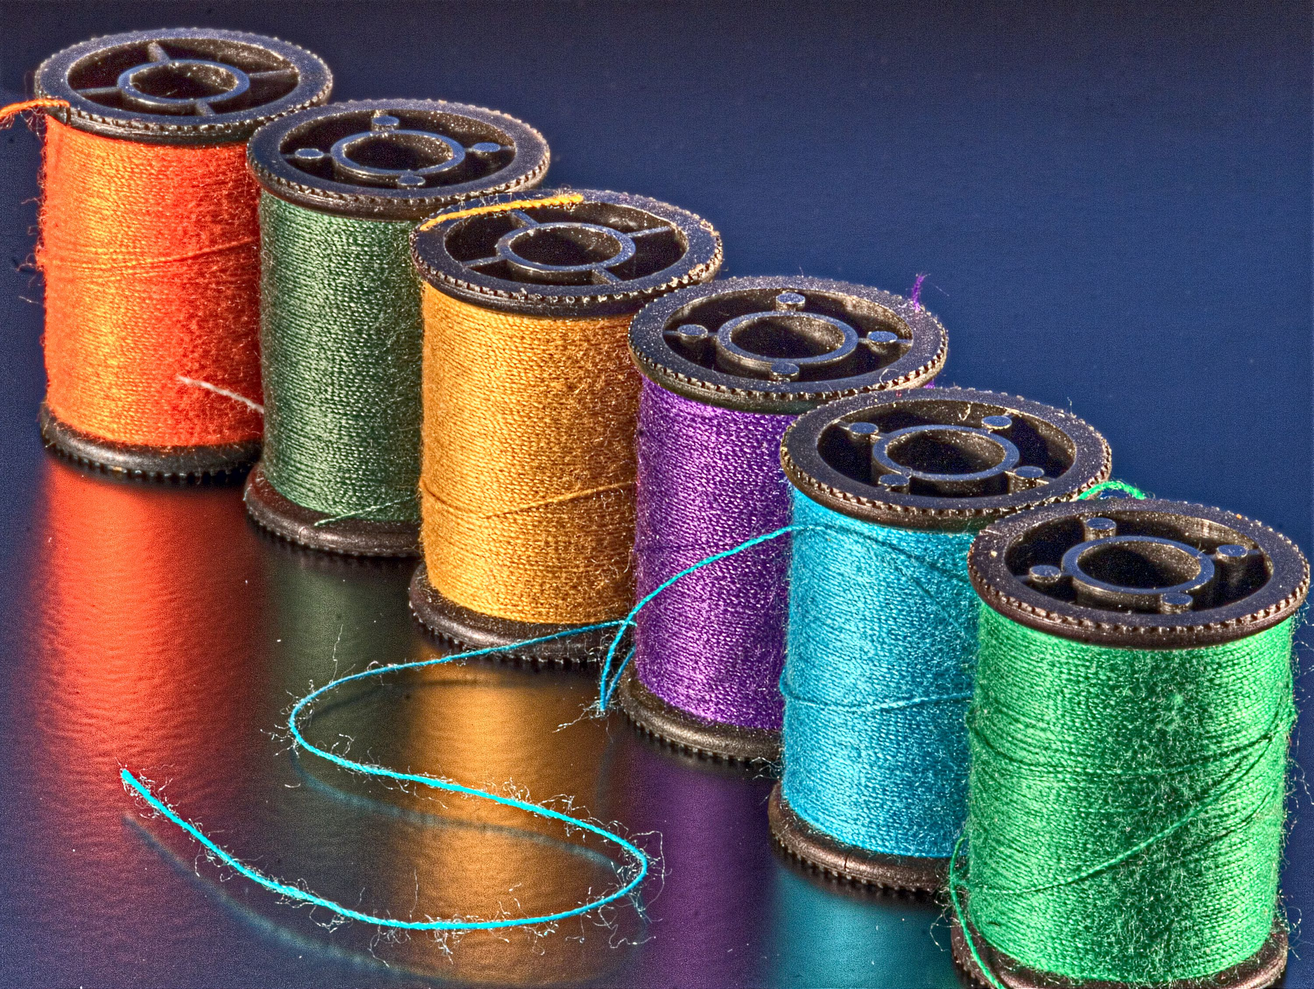

“Writing is like sewing together what I call these 'buttons,' these bits and pieces.” -Sandra Cisneros

Overview: Last semester you were given the “bits and pieces” that make up the structure of Spanish language and the cultures that speak the language. This semester, you will focus on applying those lessons to begin writing sentences and paragraphs as well as reading. You will review articles, nouns and adjectives and focus on adding the conjugated verbs to your sentence. You will use the sentences to begin practicing basic conversations.

Guiding question 1: How do parts of speech fit into writing complete thoughts in Spanish?

Lessons: Bring your interactive notebook to all lessons
Week of January 22- 26 (País: Paraguay)
___ Monday January 22nd: Review parts of speech and how they fit into sentence structure
___Tuesday, January 23: No lesson today, begin your passport work and notes on this week’s lesson
___Thursday, January 25: No lesson today, begin your follow up work creating sentences. (Spanish 1 review: Demonstrative adjectives)
___Friday, January 26: No lesson today self- reflection/assessment and optional presentation day. Read short excerpt and write three sentences describing what you read

Week of January 29- February 2(País: Peru)
___ Monday, January 29: Pronunciation Lesson ( Practice reading what you wrote)
___Tuesday, January 30: No lesson, begin your passport work.
___ Thursday, February 1: No lesson today, begin filming your oral practice
___ Friday, February 2: No lesson today. Oral presentation

Week February 5- 9 (País: Puerto Rico)
___ Monday, February 5: Introduction to conjugating in the past tense
___ Tuesday, February 6: No lesson, begin your passport work.
___ Thursday, February 8: No Lesson: Play a game, take a practice assessment, prepare for oral presentations
___ Friday, February 9 : No lesson – Quiz day

Week February 12- 16 (País: Uruguay)
___ Monday, February, 12: Lesson on new vocabulary and more prepositions
___ Tuesday, February 13: No Lesson Today. Complete your passport work
___ Thursday, February 15 : No School
___ Friday, February 16: No School

Group work: You will be able to work in groups to complete your research on the weekly Spanish speaking country and other follow up work.

Week of January 22-26
- Complete Paraguay passport Due: Friday, January 26th
- Choose one: Play a matching game, symbolize sentences with noun, adjective and article symbol, write a dialogue using greetings, and other information from last semester’s lessons
- Create your own follow up or extension

Week of January 29 – February 2
- Complete Peru Passport : Due by Friday, February 2nd
Choose any of the options below
- Using some of the recipes from the countries you have researched thus far; Create a menu or travel- guide with a friend. Due: Thursday, January 30th
- Find a song with roots in one of the countries you have researched thus far and, either learn to play it, sing it or translate it and play it for the class (see interactive notebook hand out) Due: Friday, February 2nd
- Create a game to review: Sentence structure or pronunciation

Week of February 5- 9
- Complete Puerto Rico passport Due by : Friday February 9th
- Find a partner or create a group to review and assess each other’s learning
Choose any of the following:
- Conduct research on an artist/ performer from Puerto Rico and prepare a visual presentation Due date to be determined
- Do research on how Puerto Rico became part of the United States and the Puerto Rican leaders that fought to keep Puerto Rico as a sovereign and independent country.
- Write a song to music from Puerto Rico and recruit friends to help you perform it. Due Per students requested date: See sign- up sheet, located in classroom, near three-part card organizer.
- Research the Afro Latino influence in Puerto Rico and how it was that African Roots started in the island.

Week February 12-16
- Find high schools in the countries you have researched and come up with a time line to contact them to find a skype/pen-pal Due: February, 16th

Individual work
Week of January 22- 26 (País: Paraguay)
___ Due: -Monday, January 22: Place your lesson information in your interactive notebook and choose a way to demonstrate how you will learn and study the lesson (Example: Create flashcards, record practicing the pronunciations learned, write a short commercial/skit applying using the sentences you wrote. (See Google Classroom for more details)
___Due –Tuesday, January 23: Complete First part of Passport (DUE TODAY) and follow up work of your choice (See environment reminders/handouts etc. of work you can choose/ engage in or create. (See Google classroom )
___ Due: Thursday, January 25: Complete the assignment on sentences in google classroom (Hard Copy Handout available in class as well). Organize your notebook.
___Due -Friday, January 26: Turn in Reflection and Interactive notebook -DUE TODAY

Week of January 29- February 2 (País: Peru)
Due: -Monday, January 29: Place your lesson information in your interactive notebook and choose a way to demonstrate how you will learn and study the lesson (Example: Create flashcards of pronunciation, create a game card stack of pronunciation questions, record a song or read a short excerpt in Spanish to a friend)
Due –Tuesday, January 30: Complete First part of Passport (DUE TODAY) and follow up work of your choice (See environment reminders/handouts etc. of work you can choose/ engage in or create. (See Google classroom)
___ Due: Thursday, February 1: Complete the visual presentation request if you are making a presentation this week. Complete listening and Speaking activity on google classroom
___ Due: Friday, February 2: Presentations due today
Week of February 5-9 (País: Puerto Rico)
___ Due: Monday, February 5: Complete review activity on conjugations and make flip chart of past tense “AR” verb conjugation
___ Due: -Tuesday, February 6: Finish First part of Passports(DUE TODAY). Make sure you wrote notes on this week’s lessons
___ Due: Thursday, February 8: Use your interactive notebook to create a game or “practice test” for assessing your learning for this month.
___: Due Friday, February 9: Complete Quiz

Week 4 February 12-16 (País: Uruguay)
___ Due: Monday, February, 12: Write notes on the “Preposition Lesson” and include your new vocabulary. Google classroom activity due today.
___ Due: Tuesday, February, 13: Complete all of your Passport -DUE TODAY.
___ Thursday, February, 15: No school.
___ Due: Friday, February, 16 No school

Assessment
___Friday, January, 26 : Interactive Notebook Due ( Please make sure your week’s lessons ,along with your follow up work, are all included in the notebook)
___ Friday, February 2nd : Presentations
___ Friday, February 9th: Cumulative Assessment

Extensions
See your interactive notebook, “Challenges and Extensions” and have fun completing as many tasks as you want.

Readings:
Week 1: Google classroom
Week 2: Handout
Week 3: Google classroom

Links
Duolingo.com
Quizlet.com
ClassZone.com
Google classroom invitation code: 5fxmsj7

Your Notes:

