Environmental Science: Ecosystems

Essential Understanding:
1. Earth’s ecosystems are interconnected by biological, chemical, and physical processes. Changes in one ecosystem may have local and/or global consequences.
2. Organisms both cooperate and compete in ecosystems. The interrelationships and interdependencies of these organisms may generate complex ecosystems that are stable over long periods of time and tend to have cyclic fluctuations around an equilibrium.
3. Ecosystems undergo major changes as a result of such factors as climate change,
introduction of new species, and habitat destruction. These can be the result of natural processes and/ or human impact.
4. Changes in the physical, chemical, or biological conditions of an ecosystem can alter the diversity of species in the system. Over time, ecosystems change and populations of organisms adapt, move, or become extinct.
5. The carrying capacity for a specific population in an ecosystem depends on the resources available. Given adequate biotic and abiotic resources and no disease or predators, populations increase at rapid rates. Resources, (limiting factors), predation and climate, limit the growth of populations in specific niches in an ecosystem.
6. Populations can increase through exponential growth. Higher populations result in competition for limited resources and increases in environmental pollution.
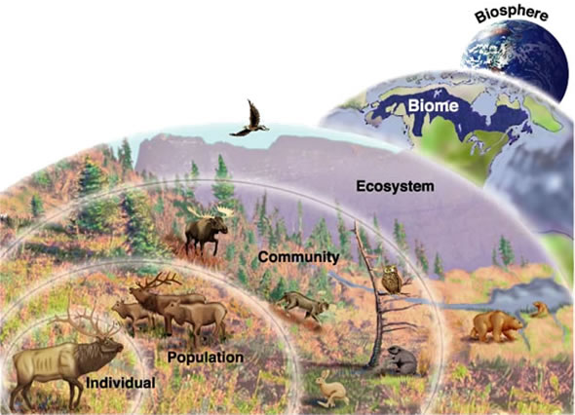
“Ecology and spirituality are fundamentally connected because deep ecological awareness, ultimately, is spiritual awareness.” -Fritjof Capra

Overview
Why are there so many living organisms on Earth, and so many different species? How do the characteristics of the nonliving environment, such as soil quality and water salinity, help determine which organisms thrive in particular areas? These questions are central to the study of ecosystems—communities of living organisms in particular places and the chemical and physical factors that influence them. Learn how scientists study ecosystems to predict how they may change over time and respond to human impacts.

Guiding question: How can change in one part of an ecosystem affect change in other parts of the ecosystem?

Individual work
_____ Read Study Guide (01/16)
_____ *Participate in the lessons:
- Major Terrestrial and Aquatic biomes:
  - Pg3-8 (01/16)
- Energy Flow Through Ecosystems:
  - Pg8-12 (01/19)
- Population Dynamics:
  - Pg16-18 (01/23)
- Regulation of Ecosystem Functions/Ecological Niches
  - Pg18-20 (01/26)
- Evolution and Natural Selection in Ecosystems
  - Pg23-36 (01/30)
_____**Reflect on the answer to Guiding Question: (02/06)

*Participation in lesson varies every week, including but not limited to taking notes, article review, worksheet
**Reflection: paragraph form submitted to Google Classroom

Group work/ Lab Work (to be announced in class)
Labs will be done in groups of 4 or 5.
Lab Handouts: There will be a pre-lab for students to complete before the lab experiment, during the lab the students will gather the necessary data to complete the lab and answer the questions associated with the topic. After the necessary data is collected students will work on completing their lab notebook.

Lab Notebook: Every student is required to keep a lab notebook. The lab notebook will be each student’s personal “copy”. You will receive specific instructions on the lab notebook requirements.

This notebook will be graded on proper usage and completeness. The lab notebook will be checked once a unit on the day of the assessment.

Formal Laboratory Report: Each quarter students will put together a formally written laboratory report. This laboratory report is done individually (plagiarisms is not allowed). The report must be typed and include; Title, Purpose, Procedure, Materials, Observations, Data, Results, Conclusion and Citations.

How do I put it altogether?
_____Ecosystem Research Notes (01/09)
_____Ecology definitions & diagram (01/09)

_____Socratic Seminar: Ecosystems (01/26)
_____Group project: Biome Project (02/02)
_____Review for your self-assessment (02/06)

Assessment
- Vocabulary: Provide definition/picture/or both to illustrate meaning of vocabulary word. A sentence must be written using the vocabulary word. (02/09)
- Testing your Knowledge: Self-Assessment (02/09)

NOTE: Work will not be graded if you do not have a notebook that is only used for environmental science. Please do not use your biology notebook for another class, and make sure you come prepared with a pen/pencil.

