Honors U.S Government

essential understanding
An understanding of how the government works is vital to being successful in today’s world. As students learn about the purpose and function of government they can understand how and why governments respond to crises in certain ways. .
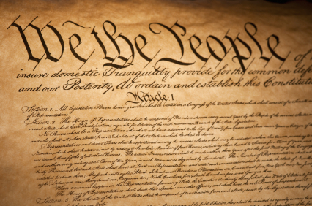

No man is good enough to govern another man without the other’s consent
- Abraham Lincoln
overview
Students in grade eleven and twelve pursue a deeper understanding of the institutions of American government. They compare systems of government in the world today and analyze the life and changing interpretations of the Constitution, the Bill of Rights, and the current state of the legislative, executive and judiciary branches of government. An emphasis is placed on analyzing the relationship among federal, state and local governments, with particular attention paid to important historical documents such as The Federalist. These standards represent the culmination of civic literacy as students prepare to vote, participate in community activities and assume the responsibilities of citizenship.
guiding question 5: How does the president use the powers the Constitution gives him?

lessons
______ The Executive branch
______ Powers of the president
______ Who advises the president?

group work

______ Choose a power that the President is given in Article II of the Constitution. As a group research what it means, how it has been used and provide examples. Discuss how this power is checked by other branches of the government. Due November 13/14

individual work

______ Read Article II of the Constitution. Prepare to participate in a socratic dialogue about the powers of the President. Due November 2/3
______ Choose a current event or topic and write a letter to President Trump. Give a thoughtful explanation of your feelings and include a solution you have to the issue. Due November 6/7
______ Choose a president from a list. Examine his presidency and answer questions about this president on classroom and be prepared to share your findings to the class. Along with this, create a digital element highlighting the accomplishments during his presidency. November 13/14
______ Participate in weekly dialogue and answer questions relating to your chosen honors book. Due November 2/3, November 9/10, November 16/17

assessment

______ Write a one page paper about how the Executive Branch operates. Due November 16/17
______ Take a 10 question assessment about the Executive Branch. In class November 16/17

guiding question 6: How does the Supreme Court influence people’s lives in the United States?

lessons

______ The Judicial Branch
______ What is the Supreme Court?
______ Court cases that shaped our nation

group work

______ As a group choose a Supreme Court case that has had a major effect on the United
States. Approve your decision with Mr. G. Research this case using the handout
provided. Due December 7/8

Some points to consider are:
    - What is the background of the case?
    - What legal issue does this case deal with?
    - What was the verdict of the case?
    - What impact did this have on U.S culture?

individual work

______Read Article III of the Constitution and participate in a socratic dialogue. Due November 27/28
______ Watch four videos about the judicial system and summarize each in a paragraph. Prepare to present your paragraph to the class. Due November 30/December 1
______ Select a judge that currently sits on the Supreme Court. Research about this judge and
Create an infographic on that judge. Due December 4/5
______ Participate in weekly dialogue and answer questions relating to your chosen honors book. Due November 30/ December 1, December 7/8

assessment

______ Write a one page minimum paper about the power of the judicial system and how it has changed the United States. Due December 7/8
______ Take a 10 question assessment about the Judicial branch. In class December 7/8

guiding question 7: What rights are guaranteed with the amendments of the Constitution?

lessons

______ How amendments to the Constitution are passed
______The Bill of Rights

group work

______ As a group choose one of the following rights granted by the first and second amendments to the Constitution: Freedom of Speech, Freedom of Religion, Freedom of the Press, Freedom of Assembly, or Freedom of Petition. Due December 18/19

individual work
______ Choose an amendment from a list and answer questions about it. Prepare to present this information to the class. Due December 14/15

______Outline the process of amending the constitution. Show how this occurs. Due December 18/19
______ Write a two page paper on articles IV - VII of the Constitution, discuss their meaning and purpose. Due December 18/19

______ Participate in weekly dialogue and answer questions relating to your chosen honors book. Due December 14/15 December 21/22

assessment

______ Take an in class assessment about the amendments and the process of amending the constitution. In class December 21/22

final
______ Take a final assessment answering questions about topics discussed during the semester
In class December 21/22

