World Cultures

essential understanding
Students will gain a greater appreciation for diversity as well as a heightened sense of awareness for the world in which they live.

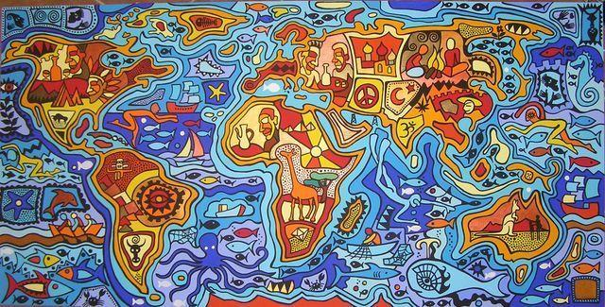

“All I ever wanted was a world without maps.”

- Michael Ondaatje

overview
In this course, students will study origins of our physical world, diverse cultures, and patterns of interaction. In addition, this course emphasizes geographical awareness, and students with physical geography, cartography, their own environment, the world economy, and current global concerns. In addition to the primary text, literary pieces and hand-outs, students utilize the internet and media publications for research and work on the identification of major geographical markers on a world map using a variety of learning modalities. Working individually and in groups, students develop projects, make presentations, and approach synthesis questions dealing with global issues.

guiding question 1: Where did we come from and where are we going?

lessons
-Early human migrations (including Push and Pull takeaway and class notes)
-Continental geography and the world’s oceans

group work
Due: November 2nd (Sections 1&2) & 3rd (Sections 3&4)
_____Native Peoples Group Presentation: Each group will be assigned a region or continent from all the around the world and track the migration period of the native peoples. Regions include: Sub-Saharan Africa, North Africa & the Middle East, Asia, Oceania, Europe, North America and Central/South America.
-Presentations must include background information about the region itself (topography, climate, etc), detailed information about 3 chosen native populations to represent (language, historical background, location, interesting facts, population density), a map that tracks both human migration in relation to other continents & a bibliography citing all research sources.
____Group Work Productivity Log: (due daily, 2 parts, incorporated as a part of your group grade)

individual work
_____Quarter 2 Long Project
Create a supplementary, interactive lesson plan (NOT POWERPOINT) to teach the class about a topic. Lesson includes an activity/handout for students. Topics include: population density, a major country, push and pull factors for migration, climate regions, landforms, continental geography or the world’s oceans.
*Discuss due date with teacher to correspond with guiding question lesson topics.
due: November 13th (Sections 1 & 2) & 14th (Sections 3 & 4)
_____World Map Project: Students will create a color coded, poster sized, map of the world, which includes all labeled continents, oceans, cardinal directions, the equator, tropic of Cancer, tropic of Capricorn, legend with symbols
Choose 1 of the following features you wish to highlight on your world map: major countries, climate regions, population density, topographical/physical map and include this feature on your map accordingly
____Individual Work Productivity Log: (due daily, 2 parts, incorporated as a part of your individual grade)
____CNN 10: (due weekly, incorporated as a part of your individual grade)
____Achieve 3000: (due weekly, incorporated as a part of your individual grade)

assessment
due: (in class assessment) November 16th (Sections 1 & 2) & November 17th (Sections 3 & 4)
_____World Map labeling assessment: Students will label a blank world map
Due: to be announced, daily in class
Lesson Notes: After completing your lesson notes, get them checked off by the teacher (for a completion grade).

readings/Socratic seminar
Book of Peoples of the World: A Guide to Cultures presented by National Geographic
“…” from Cultural Anthropology by Nanda Warms
“Share your story: What was the hardest part of being 15?” by Malaka Garib via NPR

links
-“Immigration: Global Hot Spots”map via NPR.org
(use to complete “Human Migration” takeaway)
http://www.npr.org/news/images/2007/jun/05/immigration/#

guiding question 2: How does understanding different cultures help me better interpret the world?

lessons
-Climate, geography & topography
-Landforms & how to describe them
-Climate regions

individual work
due: November 30th (Sections 1 & 2) & December 1st (Sections 3 & 4)
____Read and mark up “Eating Christmas in the Kalahari”with preselected quotes and/or appropriate questions in preparation for Socratic Seminar on 12/16 & 12/17.
due: December 7th (Sections 1 & 2) & December 8th (Sections 3 & 4)
____Vocabulary Assignment: Students will complete vocabulary cards (or documents, google slides) including the words: the definition (from Merriam Webster), the etymology and a picture (illustrated or found online/in a magazine) associated with the word
Landforms: lake, island, peninsula, bay, gulf, straight, isthmus, cape, delta
Climate regions: equatorial, tropic, subtropical, desert, grassland, temperate
____Individual Work Productivity Log: (due daily, 2 parts, incorporated as a part of your individual grade)

assessment
due: in class December 14th (Sections 1 & 2) & December 15th (Sections 3 & 4)
____Vocabulary Quiz – Open notes (you may not use the Internet or Chromebooks)

Due: to be announced, daily in class
Lesson Notes: After completing your lesson notes, get them checked off by the teacher (for a completion grade).
Research Paper & Presentation (please set up presentation date with the teacher).
Your assignment is to research a country, continent or cultural group that has experienced a pattern of human migration now or in the past. Discuss specific push and pull factors, where people from that country immigrated to and why and an overall researched overview of their reasons behind migration as well as effects.

readings/Socratic seminar
“Eating Christmas in the Kalahari” by Richard Borshay Lee from Conformity and Conflict – Readings in Cultural Anthropology

links
Merriam-Webster Dictionary – www.merriamwebster.com
Etymology Dictionary – www.etymonline.com
Analysis of “Eating Christmas in the Kalahari” **to read in preparation for Socratic Seminar
http://blogs.baruch.cuny.edu/anthro101/2010/09/04/response-to-eating-christmas-in-the-kalahari/

