Environmental Science: Atmosphere & Oceans

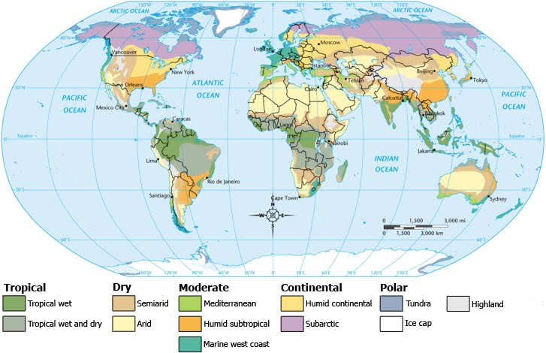

Essential Understanding:
- Key functions that the atmosphere serves to enable life to exist on the planet?
- How the atmosphere shapes Earth’s climate and weather

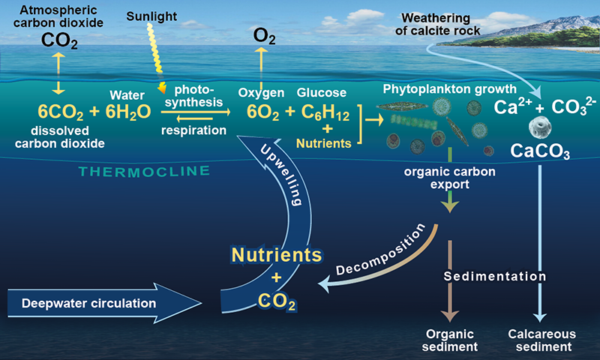
“We aren’t exactly emptying the oceans; it’s more like clear-cutting a forest with thousands of species to create massive fields with one type of soybean.” -Jonathan Safran Foer

Overview
The atmosphere is a critical system that helps to regulate Earth's climate and distribute heat around the globe. In this unit, discover the fundamental processes that cause atmospheric circulation and create climate zones and weather patterns, and learn how carbon cycling between atmosphere, land, and ocean reservoirs helps to regulate Earth's climate.
Oceans cover three-quarters of the Earth's surface, but many parts of the deep oceans have yet to be explored. Learn about the large-scale ocean circulation patterns that help to regulate temperatures and weather patterns on land, and the microscopic marine organisms that form the base of marine food webs.
Guiding question: What can cause the dynamic balance in the atmosphere to change and what influence do humans have?

Individual work
_____ Read Study Guide (10/24)
_____ Participate in the lessons:
- Vertical Motion in the Atmosphere:
  - pg11-14 (10/24)
- Atmospheric Circulation Patterns:
  - pg14-20 (10/27)
- Climate, Weather, and Storms:
  - pg21-24 (10/31)
- The Global Carbon Cycle:
  - pg24-30 (11/07)
_____Reflect on the answer to Guiding Question: (11/07)

Guiding question 2: How do ocean currents affect weather?

Individual work
_____ Introduction: Oceans
_____ Participate in the lessons:
- Ocean Structure & Composition:
  - pg2-5 (11/14)
- Ocean Currents:
  - pg6-9 (11/14)
- Thermohaline Circulation:
  - pg9-12 (11/17)
- Ocean Circulation & Climate Cycles:
  - pg12-15 (11/28)
- Biological Activity in the Upper Ocean:
  - pg15-18 (12/05)
- The “Biological Pump”:
  - pg19-20 (12/12)
_____Reflect on the answer to Guiding Question 2 (12/12)

Group work/ Lab Work (to be announced in class)
10/24: Lab Notebook Rubrics & Lab Notebook Handouts & Reviews
Labs will be done in groups of 4 or 5.
Lab Handouts: There will be a pre-lab for students to complete before the lab experiment, during the lab the students will gather the necessary data to complete the lab and answer the questions associated with the topic. After the necessary data is collected students will work on completing their lab notebook.

Lab Notebook: Every student is required to keep a lab notebook. The lab notebook will be each student’s personal “copy”. You will receive specific instructions on the lab notebook requirements.

This notebook will be graded on proper usage and completeness. The lab notebook will be checked once a unit on the day of the assessment.

Formal Laboratory Report: Each quarter students will put together a formally written laboratory report. This laboratory report is done individually (plagiarisms is not allowed). The report must be typed and include; Title, Purpose, Procedure, Materials, Observations, Data, Results, Conclusion and Citations.

How do I put it altogether?
_____Socratic Seminar: Weather & Climate (12/1)
_____Group project: The water cycle & global warming (12/12)
_____Review for your self-assessment (12/12)

Assessment
- Vocabulary: Provide definition/picture/or both to illustrate meaning of vocabulary word. A sentence must be written using the vocabulary word. (12/15)
- Testing your Knowledge: Self-Assessment (12/22)
-As a class we will decide on various options for the Final Assessment, but the due date will be 12/22/2017.

NOTE: Work will not be graded if you do not have a notebook that is only used for biology. Please do not use your biology notebook for another class, and make sure you come prepared with a pen/pencil.

