Spanish 3

…………………………………………………………………………………………………………………….

essential understanding
Spanish III will build on skills introduced in Spanish I and further developed in Spanish II.
The vocabulary will be augmented by approximately 1000 words. Grammar points will be detailed.
There will be heavy emphasis on listening and speaking skills. The goal of the class will be to
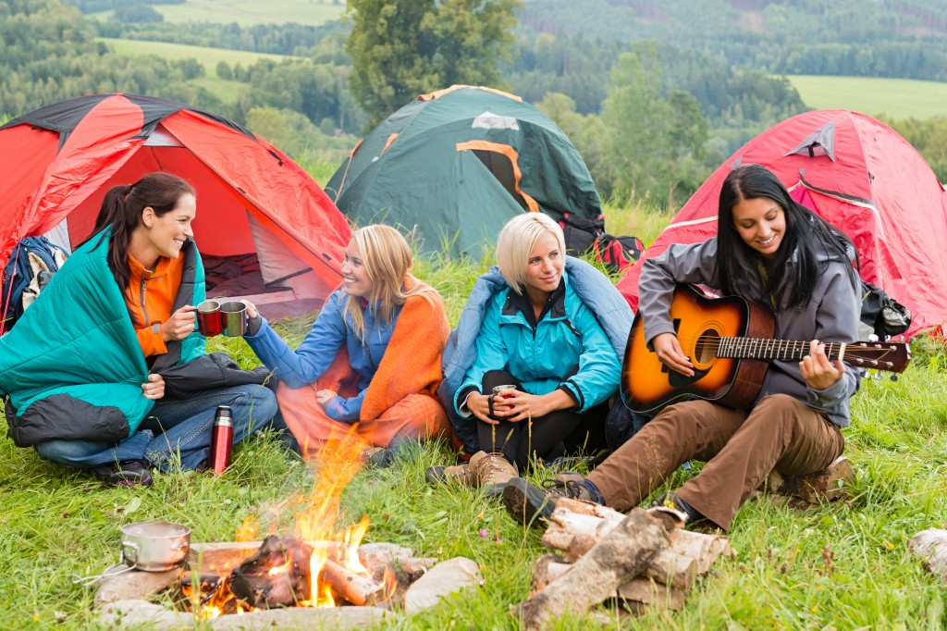
develop self-expression skills in Spanish.

“The world is a book, and those who do not travel read only one page” ~Saint Augustine

overview
In this lesson, you will learn to describe a camping trip, talk about what you did with friends, and talk about nature using preterites tense of regular verbs and irregular preterites.

Guiding question 1:
How are irregular verbs conjugated in the preterit used in leisure activities?

Lessons
_____Camping and nature vocabulary
_____ Preterite Tense of Regular and Irregular Verbs
_____ Irregular Preterites

WEEK ONE- Individual Work – Due Sept 8th
______1. Opening lesson: Lesson theme: Vamos a campar!/ Let’s go camping!
______2. Culture: Compare the nature and geography of Mexico and the US Pg. 28-29
______3. Vocabulary: Camping, hiking, and other outdoor activities. Pg. 32-33
_____ 4. Practice vocabulary: Make a mind-map: In the center, write el campamento. In attached cirlcles, write key phrases from the vocabulary (ex; la tienda de campar, el saco de dormir, el equipo, hacer caminatas). Pg. 35

WEEK TWO- Individual Work-- Due Sept 15th
_____ 1. Grammar lesson: Preterite Tense of Regular Verbs. Pg. 37
_____ 2. Grammar practice: Draw time line and label sticky notes with short sentences to illustrate the past and present tenses. (See handout)
_____ 3. More grammar practice: Complete the worksheet by filling in the blanks with the correct Preterit tense of Regular Verbs. Don’t the accent marks. (See handout)
_____ 4. Grammar: Complete the message with the correct form of the following verbs on Pg. 38, exercise 6, 7.

WEEK THREE;
Group Work – Choose two from the following options--- Due Sept 22th
_______1. In in a group of four, describe the “perfect and fun camping trip”
_____ 2. Work in group of four and research a state or country and create a ‘trip’ poster like the one on page. 35 and entitle your poster with the preterite-tense verb in the ‘yo’ form.
_____3. Prepare an interview to find out about a trip your peer has taken or would like to take with their family. Interview each other. (See handout for interview questions)
_____4. Create a brochure for a camping trip in Spanish and incorporating the vocabulary from the chapter. Be prepared to answer clarifying/follow up questions from the teacher and/or your peers.

WEEK FOUR- Individual Work--- Due Sept 29th
_____ 1. Opening lesson: Irregular Preterites. Pg. 42
_____ 2. Grammar practice: Complete the sentences according to the model. Use the verb in the proper form of the preterite. Exercise 13, pg. 43
_____ 3.Irregular preterite song; watch a video with a song about the irregular preterite verbs in Spanish. While watching the video, fill out a chart that show the stem-changes that make these verbs irregular.
_____ 4. Review Irregular verbs
_____ 5. Grammar and vocabulary quiz. Due 9/29

WEEK FIVE--- Group Work- Due Oct 6th
_____ 1. Listen to the audio about a poster on p. 35 and answer true/false questions saying why a statement is false.
_____ 2. In pairs, conjugate 3 verbs of your choose in the preterite tense, write two things you learned in class and write one question for the teacher. This will be collected as an informal, formative assessment.
_____ 3. In pairs, read the dialogue on pg. 45 and analyze the situation with a flow chart.(. See example on pg 45-46

Assessment- Due Oct 13th
Part 1.
Newspaper Advertisement: You have obtained a summer job as a Camp Counselor for Great Adventures Summer Camp in Yosemite, CA. Your boss has just informed you that because you are bi-lingual he would like for you to create an advertisement in Spanish that will recruit Spanish speaking children to your two week overnight camp.
Write and advertisement for the camp: Your advertisement should provide information about the climate, the geography, activities provided, the cost and age groups. Don’t forget the contact information and a couple of pictures of last year’s campers.
Part 2.
Grammar and vocabulary studied in class.

