Science Fiction Cinema

Essential understanding
The purpose of Science fiction “is to use science fiction as a vehicle for critiquing current issues and events, and [to use] the knowledge we construct to consider perspectives on what the future might hold.” Keeping in line with the purpose, the ultimate goal of this elective is to teach you to read science fiction critically and to draw relationships between what you read and actual events in the real world. In accomplishing this task, you will have learned just one of many means by which you can examine critically the current events of our time.

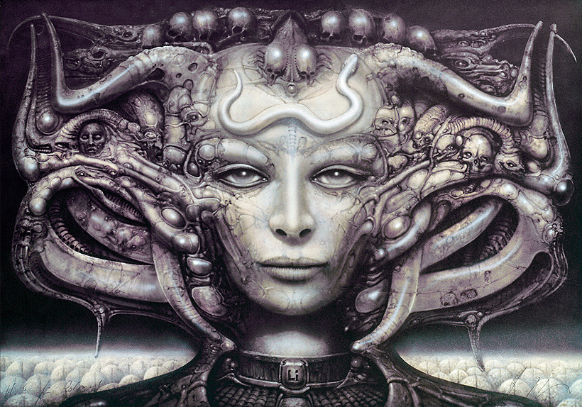
“Today we live in a society in which spurious realities are manufactured by the media, by governments, by big corporations, by religious groups, political groups... So I ask, in my writing, What is real? Because unceasingly we are bombarded with pseudo-realities manufactured by very sophisticated people using very sophisticated electronic mechanisms. I do not distrust their motives; I distrust their power. They have a lot of it. And it is an astonishing power: that of creating whole universes, universes of the mind. I ought to know. I do the same thing.”
―Philip K. Dick

Overview
This course will examine science-fiction films—both historical and contemporary—focusing on the issue of what constitutes, and is opposed to, “the human,” whether the “non-human” is technological, alien, or monstrous. In this context, the course addresses representations of gender, sexuality, race, and class, as well as concepts of “posthumanism,” within science fiction cinema.

guiding question 1: Does human nature stay consistent regardless of setting?

Lessons
_______8/30: WEEK 1: INTRODUCTION

______9/6: WEEK 2: HUMAN LIFE/MECHANICAL LIFE

______9/13: WEEK 3: THE POEM AND THE COMPUTER

______9/20: WEEK 4: BOUNDARIES, BODIES, AND MACHINES

Group work
_____ Socratic Seminars at the end of every class (create discussion questions using lesson topics, readings, and films)

_____ 8/30 Screening: Metropolis (26 Germany) Fritz Lang (124 m)

_____9/6 Screening: Alphaville, une étrange aventure de Lemmy Caution (65 France) Jean-Luc Godard (95 m)

_____9/13 Star Trek: The Next Generation, “The Best of Both Worlds, 1 & 2” (90 US) Cliff Bole (100 m)
_____9/20 Star Trek: First Contact (96 US) Jonathan Frakes (111 m), which continues the Borg saga of “The Best of Both Worlds” television episode

Individual work
____Personal Reflections (every class)
You will keep a journal in which you will reflect on class readings and discussions. The writing can be exploratory in nature, it can be expressive of your personal opinions, and it should also explore your own thinking through lesson topics, readings, and Socratic Seminars.

Assessment
____ Due 9/27/2017 ---- For the final project you will demonstrate your ability to analyze
science fiction critically. This critical analysis includes three important skills:

1) The ability to read science fiction and discover relevant themes and values. These
themes and values may be those of the director, those of your own, or those of a
given culture’s.
2) The ability to think about these themes and values in relation to current events, or
the events of the author’s time. And finally,
3) The ability to extrapolate on the intersection between science fiction and the present
in order to construct some kind of interpretation of what the future might hold.

Now, you have the opportunity to show how well you can engage in this process on
your own. You may do this through one of the following film options listed in Sci-Fi Lists - Top 100 Sci-Fi Films (http://scifilists.sffjazz.com/lists_film.html).

Extensions
See Mx./Mr. Almanza

Readings
David Desser, “Race, Space and Class: The Politics of Cityscapes in Science-Fiction Films”
R. L. Rutsky, “Metropolis: Between Modernity and Magic”
ANNA E. HILLER--- DYSTOPIA 101: THE MILLENNIALS REACT TO METROPOLIS
Chris Darke, “Light that goes, Light that returns” from Alphaville

links

