Spanish 4 Name:

Session:

…………………………………………………………………………………………………………………….

essential understanding
In this lesson, students will learn to talk about art and music and ask and answer questions about their classmate’s interests in art or music and if they play an instrument.
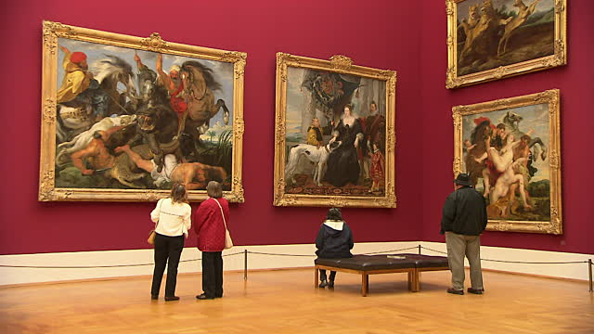

“Tell me and I forget. Teach me and I remember. Involve me and I learn”~ Benjamin Franklin

overview
In this lesson, students will learn to talk about art and music, talk about events that will have happened at a certain time in the future. Students will use the following vocabulary and structures: words and expressions about art and music, future perfect and the conditional perfect, and relative pronouns.

Guiding question 1:
How is use the future perfect and conditional perfect in Spanish?

Lessons
_____ Future perfect
_____ Conditional perfect
_____ Relative pronoun

WEEK ONE- individual work Due 9/1
______1. Apertura de lección: Introduction of new vocabulary about art and music. Pg. 182-184.
______ 2. Practica de vocabulario: Choose the appropriate answers to the following questions on page 185.
______3. Escribir: Give the definition or the equivalent of the following on pag 185, exercise.
______4. Leer: Read pg.187 and pay attention how the lesson vocabulary is used in the maganize Maria Elena is reading. Then, answer questions on pg 188 about the article and talk about the art and music you like.
_____ 5. Spelling game on words and terms related to music and painting.

Group work- Choose one for the following – Due 9/8

____ 1. Suppose that you and your classmate are in an art gallery, where the works of a famous painter are exhibited. Use your imagination to answer the following questions. (See Pg. 189)
____ 2. Prepare an art class for elementary school. Play the role of two instructors who are going to offer an art class in an elementary school. Talk about the materials they are going to need, what are you going to teach the children and what are you going to do to awaken in them the love of art. Present the lesson to the class.

Assessment-
^{Due 9/15}
Part 1- Answer the following questions:
a) How is use the future perfect and conditional perfect in Spanish?
b) How is use the relative pronouns in Spanish?

Part II
a) Spelling vocabulary learned in class about music and painting.
b) Write a letter to your best friend about what you learned in class about music and painting. Make sure use the future and the conditional perfect in your letter to your friend.

