World Cultures

essential understanding
Students will gain a greater appreciation for diversity as well as a heightened sense of awareness for the world in which they live.

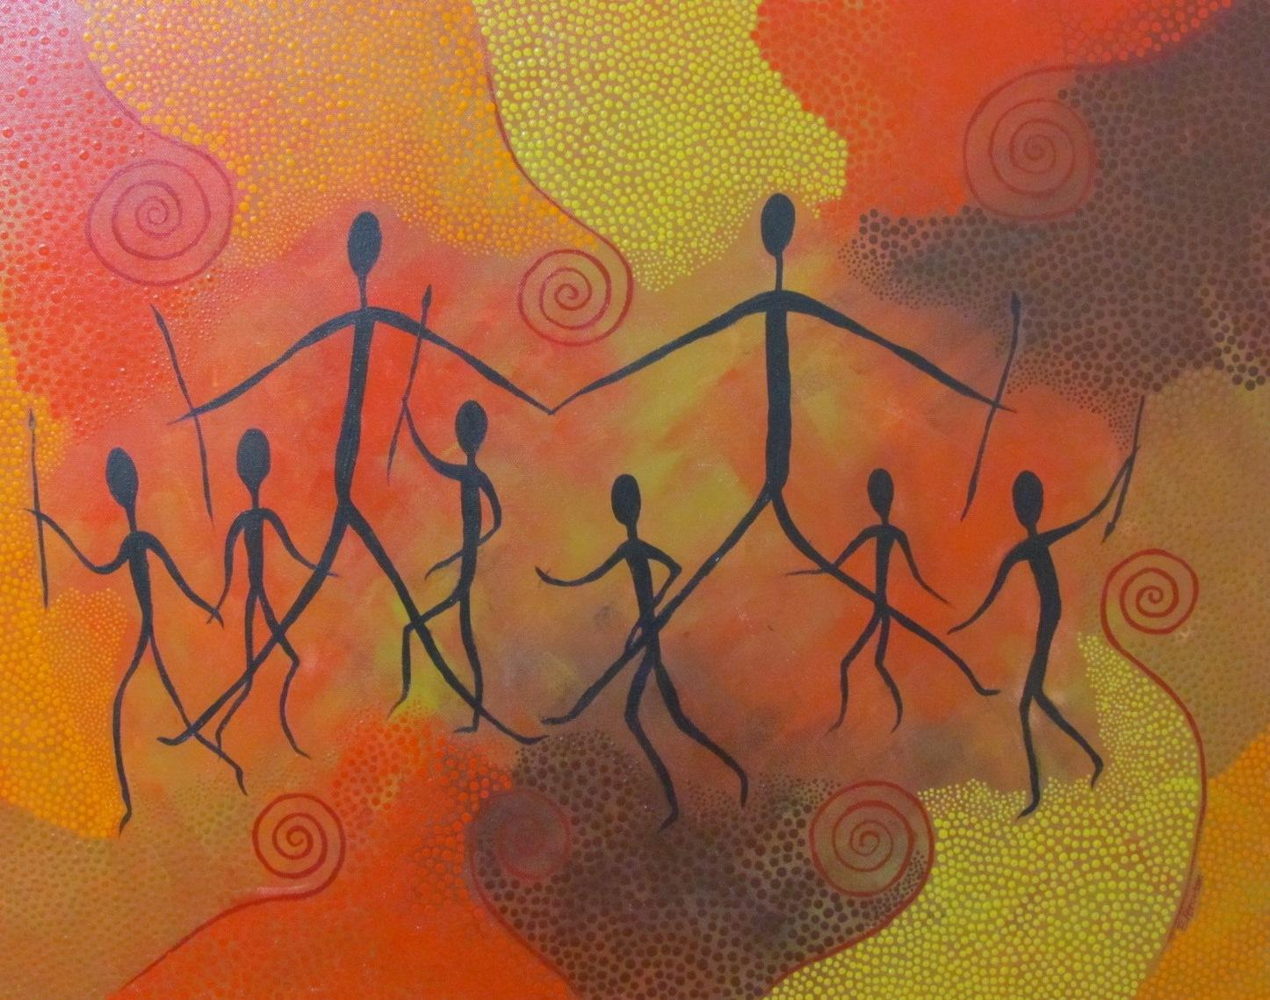

“Let’s honor all living things that have come before us in this place.” –Indigenous Custom

Overview
In this course, students will study origins of our physical world, diverse cultures, and patterns of interaction. In addition, this course emphasizes geographical awareness, and students will study physical geography, cartography, their own environment, the world economy, and current global concerns. In addition to the primary text, literary pieces and hand-outs, students will utilize the internet and media publications for research and work on the identification of major geographical markers on a world map using a variety of learning modalities. Working individually and in groups, students will develop projects, make presentations, and approach synthesis questions dealing with global issues.

Guiding Question 1: What are the needs of humans?

Lessons
-The needs of humans according to cultural anthropology & Culture
-Genealogy
-“The Human Family Tree”

Individual work
Due: August 28th (Sections 1 & 2) or August 29th (Sections 3 & 4)
____What do you need to survive? Write a list of all the items you believe you need in order to survive.
Due: August 31st (Sections 1 & 2) or September 1st (Sections 3 & 4)
____What is something distinctive of your culture? In class on August 28th or August 29th brainstorm with a partner and discuss essential items, events or celebrations that belong to your culture. Pick one item on which you want to focus.
Choose 2 options of the following to be checked by the teacher: Bring in the item, draw an illustration of the item, find a picture of the item, show on a map where it is found.

Assessment
Due: September 7th (Sections 1 & 2) or September 8th (Sections 3 & 4)
____Cultural Artifact Write up: Write and submit one paragraph to one page about the item or event you chose that is distinctive to your culture. Describe why it is important to your culture AND why you personally appreciate or treasure it.
Due: September 14th (Sections 1 & 2) or September 15th (Sections 3 & 4)
____ “The Human Family Tree” Takeaway: Write a one page takeaway about the National Geographical Film “The Human Family Tree.” In your writing, connect the movie to what you have learned so far in World Cultures about the needs of humans, culture, anthropology and genealogy.
Due: to be announced, daily in class
Lesson Notes: After completing your lesson notes, get them checked off by the teacher (for a completion grade).

Extensions
Due: see teacher to schedule due dates at the very beginning of the quarter … no exceptions!
___Presentation or Essay: Make a presentation (to present to the class) or write a 5 paragraph essay (to turn into the teacher) about your personal culture. Project must include research with citations in MLA format, which includes - significant cultural artifacts, a map of where people from your culture originated, specific traditions, cuisine and important facts about your culture. Also, include a component describing your personal history and connection.

Readings/Socratic Seminar
Date:
Book of Peoples of the World - “The Genographic Project”

Links
-23andMe Academic: Genetics in the Classroom - www.23andMe.com
-Human Prehistory 101 Videos
-NewsELA – Nonfiction Literacy and Current events – www.newsela.com
-Citation Machine – automatic citation creator – http://www.citationmachine.net/

Guiding Question 2: How does where you live shape your identity and perspective?

Lessons
-Navigating maps & their uses
-Pedagogy of Place

Group work
Due: September 28th (Sections 1 & 2) or September 29th (Sections 3 & 4)
____Navigating Maps Group Project & Presentation: Compare and contrast 3 different types of maps (country map, world map, physical map, subway map, street map, etc.). Include the functions of each maps, examples of the maps, a guide to the symbols & color-coding used in each map, and how they are useful.
Presentation must also include a vocabulary section, including the following words : map, globe, longitude, latitude, equator, topography, density, legend, point of interest, compass rose, cardinal directions
due: daily, in class
____Group Work Productivity Log: (2 parts, incorporated as a part of your group grade)
- At the BEGINNING of group work time: meet with your group, make a plan and record in the binder what you plan to accomplish in that group work period and what each group member specifically plans to do.
- At the END of group work time: Briefly reflect with your group, answer what did you accomplish, how you feel about it and what do you plan to accomplish next time and/or for homework

Individual work
Due: October 12th and 13th
____Pedagogy of Place Project & Gallery Walk: The objective of this project is to learn specifically about where you live or come from! They will be displayed in a class gallery walk.
Choose one (1) - Create a map of the city of Hayward, a detailed map of your specific neighborhood or a map of what you consider your hometown (check in with teacher to get approved).
Please include: a legend, symbols, street names, land forms, bodies of water, points of interest, your home and more! *Choose/label one specific landmark that sticks out to you in your mind and describe why.
due: October 21st & 22nd
____Exploration and Curiosity Project: Students will plan an international travel experience. This fantasy vacation must include pictures, country location on maps, total travel duration (considering time zones, flight times), points of interest and tourist destinations.
Choose your format! - Journal entries, Prezi/Powerpoint, time line, blog, or a creative idea approved by the teacher.

Assessment
Due: September 30th and October 1st
_____Group Work Self-Evaluation (in class)
_____Maps & Navigation Vocabulary Synthesis (in class)
Due: October 21st and 22nd
***entire essay MUST be written completely in class, you may use class notes to assist you.
____In Class Synthesis: Respond in 1 paragraph to the guiding question - How does where you live affect your identity and influence your perspective? What does this identity have to do with points of interest on the map you created (keep in mind the special place you identified)? Cite specific examples from your individual work, group presentations and lessons.

Extensions
-Continue to work on “Tales from the Genome – Introduction to Genetics for Beginners” online curriculum. Provide the teacher with updates of your progress, lesson by lesson.
Access URL: www.udacity.com/course/bio110

Readings/Socratic seminars
“Will wearable tech turn humans into cyborgs?” from NewsELA

“Migrant crisis grows: Hungary blocks access to trains; 11 drown off Turkey” from NewsELA

