Spanish 2 Name:

Session:

…………………………………………………………………………………………………………………….

essential understanding

Many people like to practice sports. Practicing sports offers numerous health benefits, which include improved lung and heart function, as well as reduced medical conditions such as high blood pressure and osteoporosis, or reduced bone density. While practicing sports, you exercise motor and cognitive skills, which are essential both on and off the field. Practicing sports also supports weight loss and enhances your quality of life by encouraging healthy habits. What type of sport do you practice on a daily basis?
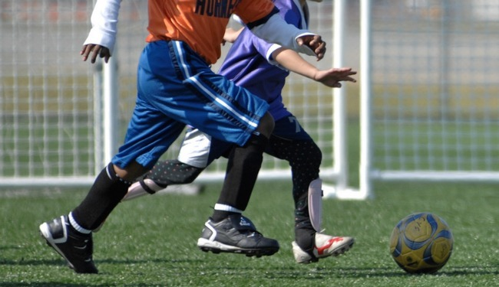

“ Finding good players is easy. Getting them to play as a team is another story”.
-Casey Stengel

Overview
In this lesson you will learn how to talk about sporting events and athletes; discuss ways to stay healthy; point out specific people and things, and retell events from the past.
Guiding question 1:
- How do you conjugate in Spanish the regular verbs in the Preterite that end in -er, -ir ?
Lessons
- _____ Describe types of sporting events and athletes /vocabulary presentation
- _____ Discuss ways to stay healthy by practicing sports.
- _____ Retell events from the past
- _____ Grammar- Adverbs with- ment
- _____ Grammar- Preterite er - ir
- ______Demonstrative adjective and pronouns

WEEK ONE- individual work
Due on Friday 11/ 18
______1. Lesson opener, pp 88-89: ¡Argentina La copa mundial
______2. Presentación de vocabulario. Translate the blue words on pp 90 & 91 into English. Due 11/2
_____ 3. Pratica de Vocabulario p 92. exercises 1,2 p 92. 11/3
_____ 4. Vocabulario en contexto p 93, 94 exercises 4 p94. 11/4
_____ 5. Quiz #1 on vocabulary about sports due 11/18

Group work –
Choose one of the following
_______1. Project: Investigate on the internet the life of a famous soccer player (Biography) who participated of the last world cup (2016). Present to the class in powerpoint form. Due 12/01.
_____2. Project: Investigate on the internet the life (biography) of a famous Basketball Player in USA who participated of the last (2016) Baseball World Series. Due 12/01

Week two- Individual work
December on 16 th.
_____ 1. Lesson opener: Presentación de gramática, p 95: Regular Preterite of - er, -ir and adverbs Powerpoint note.
_____ 2. Textbook practice: pp 96 exercises 5,6 due 12/08
______3. exercise 7, 8 & 9 p.97 . due 12/10
_____ 4.Gramática en contexto: Read Telehistoria escena, notice how the verbs in action are used in the dialogue. Then practice using the verbs on the following page 99., actividades 10-11-12. due 12/12
_____ 5. Quiz #2. on grammar (preterite -er, -ir, and adverbs) due 12/16th
Group Work-
Due December 15th
_____ 1. In pairs, research two famous Hispanic Americans Soccer Players who play on the USA soccer team: Then, create a neat poster with their biographies, including family and education background. Due 12/15

Assessment- due 12/16
a) How do you conjugate the Preterite - er-ir ?
b) Adverbs with mente
c) Vocabulary: Describe sporting events and athletes
d) Grammar test (Demonstrative adjective pronouns)

