Spanish 3

Name:

Session:

essential understanding

Theme : Por un futuro mejor

“A good citizen is a person who obeys the laws of his country, contributes to society and participates in public affairs with wisdom. Good citizenship is closely tied to the concept of civic duty, the idea that citizens have responsibilities they must fulfill with regard to their country. Being a good citizen is important in caring for others, respecting the law, protecting the environment and improving the community. Citizenship can be defined as membership of a particular community or country and building good relationships with people within the community. It involves adhering to the rights laid down by the law and living according to the social and moral standards” https://www.reference.com/world-view/mean-good-citizen.
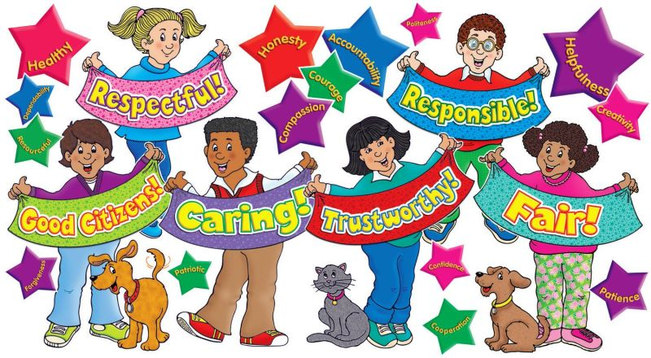

“ To be a good citizen, it's important to be able to put yourself in other people's shoes and see the big picture. If everything you see is rooted in your own identity, that becomes difficult or impossible. Eli Pariser

Overview
In this unit the students will learn new vocabulary relating to government, society, and business. Then practice the vocabulary to talk about ways of achieving sucess. In adition, they will learn the present subjunctive of verbs.

Guiding question 1:
What does it mean to be a good citizen?
Lessons
______Warm ups
_____ Presentation of the new vocabulary.
_____ Discuss in the target laguage obligations and responsabilities.
_____ Gramatica –present subjunctive of regular verbs.
_____ Reading Comprehension
_____Online vocabulary and grammar activities
_____Online Games
_____Online quizzes
individual work

QUARTER 3- Part 1 – Just Vocabulary and related exercises assignments. All the individual work in part 1 is due in February 24th
______1. Lesson Opener, pp 176 - 179
______2. Vocabulary Activity: Translate the blue words on pp. 178 & 179 into English.
_____ 3. Exercises 1 and 2 page 180.
______ 4 .Exercises 3 page 180 .
______5. Read the text “ Folleto técnico” page 181 and do the exercise 4 page 182.
_____6. Spanish Vocabulary Booklet - Use all the vocabulary learned in this lesson and make a booklet with pictures and the meaning/translation of each word. This activity has to be done in a Google slide show. 02/15th.
______ 8. Walk day gallery 02/17th
QUARTER 3- Part 2 – Just grammar exercises. All due in March 28TH.
______1. Lesson opener. Grammar page 183
______2. Exercise 6 “ Es importante” p 184.
______ 3. Exercise 8 “ ?Qué opineas?” page 185.
_____ 4. Exercise 9 “ Los expertos ” page 185.
______5. Read the text 2 “ Anuncio” page 186 and do the exercise 10, page 187.
______6. Exercises 11 “ Un invento novedoso” page 187.
______7 Lesson opener page 188- Grammar-More Subjunctive Verb forms
______8.. Exercise 12 “ La acción social page 189.
______9 . Exercise 13 “ Unos consejos” page 189.
______10. Exercise 14 “ Un viaje a Hoduras “ page 189 .Due 02/24
______11. Read the text “ Comparación cultural , El arte ingenuo page 190 and describe with details the street where you live. Due 02/ 28
Group work

QUARTER 3- Part 3 – Reading Comprehension assignments. All due in February 28 ^{th}.
Do the following
______1. Draw and paint a place, thing, or people of the Maya civilization. The painting needs to show cultural characteristics.
______2. American Flag time line, see the teacher’s example in Google classroom.
Assessment
_____1. Online Vocabulary quiz Feb,10 ^{th}
_____2. Online grammar quiz – Possessive Adjective March 17 th

_____3. Read Comprehension March 24th

