Spanish 2

Name:

Session:

essential understanding

Theme : Cómo me queda?

“Jibaro culture is the dominant culture in Puerto Rico and is a blend of native traditions with the conquering Spanish ones. Dress in the Jibaro style prominently borrows from Spanish style with flowing, colorful skirts for women and a basic shirt and pants for men. Men also wear straw hats, and women sometimes wear either flower bonnets or colorful kerchiefs in their hair. Bomba culture is primarily African, and where Jibaro is colorful, Bomba is mostly white. The Bomba style is related to the traditional clothing of African slaves on the island. The white dresses for women are sometimes accented with bright colors such as blue and red, while men wear colorful shirts tied at the waist with ankle-length pants. Men sometimes also accessorize with a straw Panama hat, while women leave their heads bare.” https://www.reference.com/world-view/traditional-dress-puerto-rico-like
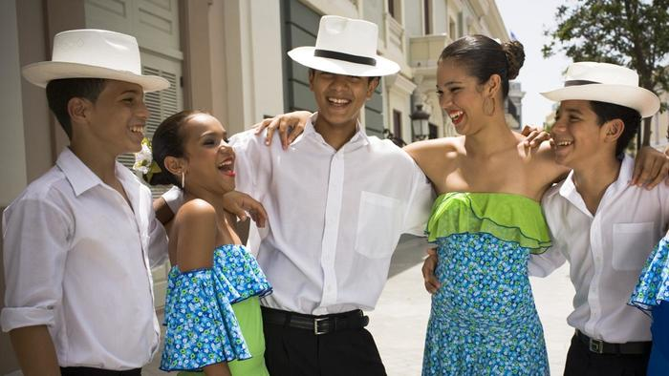
“

“Fashion is a language that creates itself in clothes to interpret reality.”
― Karl Lagerfeld

Overview
In this unit the students will learn how to talk about clothing, shopping, and personal needs. Also you will learn how to say whom things are for and express opinions. In addition, in the grammar lessons, you will learn verbs like gustar, present tense, and pronouns after prepositions.

Guiding question 1:
How many words related to clothing do you know in Spanish?
Lessons
______Warm ups
_____ Presentation of the new vocabulary
_____ Discuss clotthing/outfits and culture in Puerto Rico and Peru
_____ Gramatica –Verbs gustar, present tense, pronouns after prepsotion
_____ Reading Comprehension
_____Online vocabulary and grammar activities
_____Online Games
_____Online quizzes

individual work .
QUARTER 3- Part 1 –Vocabulary assignments. All individual work is due in February 24th
______1. Lesson Opener, pp 142- 145
______2. Vocabulary Activity: Translate the blue words on pp. 164 & 165 into English.
_____ 3. Exercises 1 and 2 page 146.
______ 4 .Exercises 3 page 146 .
______5. Read the dialogue page 147 and do the exercise 5 page 148.
_____6. Spanish Vocabulary Booklet - Use all the vocabulary learned in this lesson and make a booklet with pictures and the meaning/translation of each word. This activity has to be done in a Google slide show. 02/15th.
______ 8. Walk day gallery 02/17th

QUARTER 3- Part 2 – Grammar assignments. All the individual work in part 2 is due on March 28TH.
______1. Lesson opener Grammar page 149.
______2. Exercise 6 “ Soy único” p 150.
______ 3. Exercise 8 ? Que le doy? page 151.
_____ 4. Exercise 9 “ !Toca a ti! ” page 151.
______5. Lesson opener page 154. Due 02/16
______6. Exercises 13, “ ?Para quién és? page 155.
______7.. Exercise 14 page 155 ? Que opinias?
______8 . Exercise 15 “Fui de compras” page 156.
______9. Exercise 12 “ Sus familias “ page 175.
______10. Read the text “ Telehistoria completa, page 157 and do Exercise 19 page 158.
Group work
PART 3 – Reading Comprehension and related exercises assignments. All the assignments in part 3 are due in February 28th
Do the following:
______1 . In your group read the text “Telehistória complete 2“, page 152, take turns, search for translation, and answer the questions of the exercises 11 and 12. Each participate must turn in a copy of the work in the Google classroom..
_____2. Fashion timeline- see the teacher’s example in Google classroom.

Assessment
_____1. Online Vocabulary quiz Feb, 10th
_____2. Online grammar quiz – Possessive Adjective March 17 th

_____3. Read Comprehension March 28th

