U.S. History

essential understanding:
The history of the United States of America is steeped in controversy and triumph. From its beginnings as thirteen colonies to its role today as a super power people have fought and died for the principals and ideals it embodies. Others have fought and died to change the injustices and disgraces that were born and perpetuated throughout its history. We can gain a better appreciation of who we are today as a country by understanding where we were and how we got here.
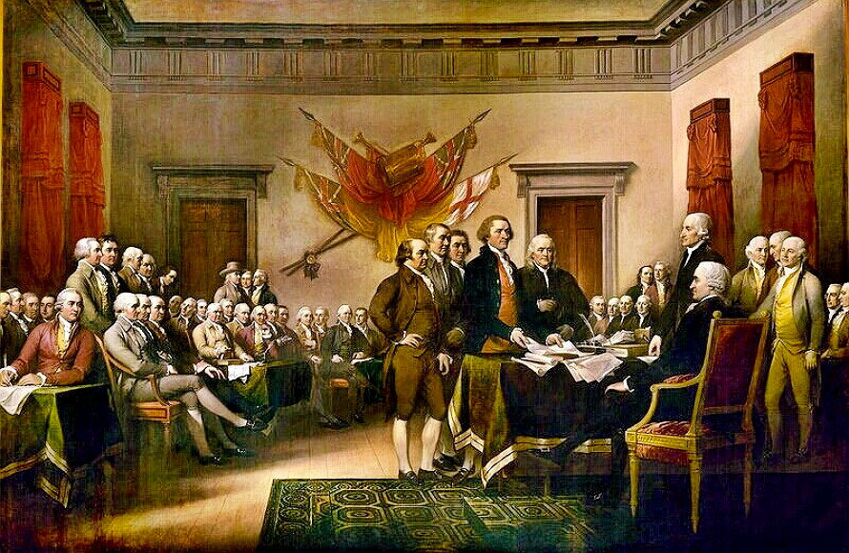

“ We are not makers of history. We are made by history”
Martin Luther King Jr.

overview
Students in U.S. History study the major turning points in American history. After a review of the nation’s beginnings and the impact of the Enlightenment on U.S. democratic ideals, students will examine the westward migration of America and its impact on our country. Students will then trace the change in the ethnic composition of American society; the movement toward equal rights for racial minorities and women; and the role of the United States as a major world power. Students will consider the major social problems of our time and trace their causes in historical events. They will learn that the United States has served as a model for other nations and that the rights and freedoms we enjoy are not accidents, but the results of a defined set of political principles that are not always basic to citizens of other countries.

guiding question1: How is a well researched history paper written?

lessons
______ The five paragraph essay
______ Plagiarism
______ How to cite sources

group work
______ As a group describe 5 ways in which people can plagiarize, what are better ways to complete an assignment that does not require plagiarism? Present your information to the class DUE September 6/8

individual work
______ In your notebook write about your own research style. How do you like to research on the internet? List any websites you use that would be good for researching. How can improve your researching skills so you don’t plagiarize and write better papers? DUE August 29/30
______ Read the article “What is Plagiarism, and Why does it Matter?”. Participate in a Socratic dialogue and write a takeaway. DUE September 1/2

assessment
______ Choose a founding father and write a 5 paragraph essay about why people consider this person a founding father. Follow the guidelines given out during the “How to cite sources” lesson. DUE September 8/9

readings
http://www.mrswatersenglish.com/2014/06/what-is-plagiarism-and-why-does-it-matter/

