Honors U.S. History

essential understanding:
The history of the United States of America is steeped in controversy and triumph. From its beginnings as thirteen colonies to its role today as a super power people have fought and died for the principals and ideals it embodies. Others have fought and died to change the injustices and disgraces that were born and perpetuated throughout its history. We can gain a better appreciation of who we are today as a country by understanding where we were and how we got here.

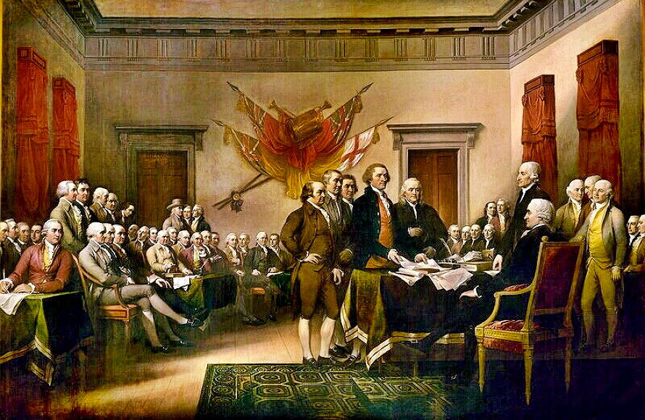

“ We are not maker’s of history. We are made by history”
Martin Luther King Jr.

overview
Students in u.s history study the major turning points in American history. After a review of the nation’s beginnings and the impact of the Enlightenment on U.S. democratic ideals students will examine the westward migration of America and its impact on our country. Students will then trace the change in the ethnic composition of American society; the movement toward equal rights for racial minorities and women; and the role of the United States as a major world power. Students will consider the major social problems of our time and trace their causes in historical events. They learn that the United States has served as a model for other nations and that the rights and freedoms we enjoy are not accidents, but the results of a defined set of political principles that are not always basic to citizens of other countries.

guiding question 4: What were the causes of the Civil War and how did the union army win the war?

lessons
______ A nation divided, the 1850’s and the coming war.
______ Lincoln and the election of 1860
______ The Civil War part 1
______ The Civil War part 2
______ Reconstruction begins

group work
______ As a group create a chart of the Civil War. Your chart should list events for each month from the years 1860-1865. The types of events should feature important battles, decisions, and turning points of the war.
In addition, choose a well known Civil War battle and research why and how it happened, find out its overall importance to the war and answer questions found on google classroom about it. Present your research to the class.
Your presentations should go deeper than other group presentations, show true understanding of the material, and strictly follow group presentation guidelines.
Due November 15/17

individual work
______ Create a timeline of important events that occurred in the United States during the years 1851 - 1870. List at least one event from each year. Events should have national importance. Do not merely list events but give detail of what happened. Due November 1/3
______ Read “Ultimate and Proximate Causes of the Civil War” pages 432-435 in “A History of the American People” and participate in a socratic dialogue. Due November 4/7
______ Read chapter nine of “A Patriots History of the United States” and write a CRC of the reading. Due November 4/7
______ Watch “America The Story of Us” episode three “Division” and episode four “Civil War,” answer questions about the video. Due November 8/10
______ Research and describe everyday life for soldiers in the civil war in a two page typed response. Include quotes from actual soldiers in your writing. Due November 11/14
______ Outline Abraham Lincoln’s reconstruction plan of the south and explain how reconstruction actually took place in the years following Lincolns death. Due November 15/17

assessment
______ Take a 15 question assessment about the Civil War and reconstruction. Due in class November 15/17
______ Primary document comparison essay: Lincolns first and second inaugural addresses. Due in class November 15/17

readings
Gettysburg Address
A Patriots History of the United States
A History of the American People

guiding question 5: How did the idea of the “west” change as the nation slowly migrated west?

