Physical Education: Hunger Games Edition

# Essential Understanding

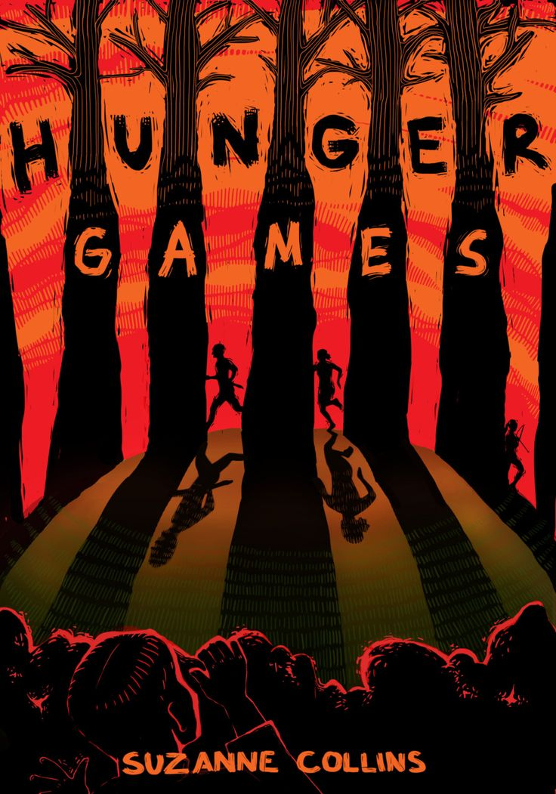

**“Happy Hunger Games! And may the odds be ever in your favor.”   
―** [**Suzanne Collins**](https://www.goodreads.com/author/show/153394.Suzanne_Collins)**,** [**The Hunger Games**](https://www.goodreads.com/work/quotes/2792775)

# Overview

A healthy mind requires a healthy body, and it is my hope to encourage students to develop an enthusiasm for sports and fitness that will benefit them all their lives. Physical education provides an opportunity to demonstrate self-discipline, self-motivation, good sportsmanship, and an opportunity to contribute to the development of social skills. It strives to promote a positive correlation between learning and physical well-being.

**Guiding question 1: What attributes are necessary for survival?**

# Lessons

# ___Survival Shelter

# ___Hydration: Finding a water source

# ___Catching Survival Fire

# ___Tools of a Survivor

# ___Survival Hunting & Gathering

# ___ Survival First Aid

# ___ Navigating & Signaling

# ___Building your own Survival Kit

# Group work

# ___4/19 Survival Shelter Project

# ___4/26 Hydration: Finding a water source Project

# ___5/3 Catching Survival Fire Project

# ___5/10 Tools of a Survivor Project

# ___5/17 Survival Hunting & Gathering Project

# ___ 5/24 Survival First Aid Project

# ___ 5/3 Navigating & Signaling Project

# ___5/31 Building your own Survival Kit

# Individual work

__4/5 Mid Arena Fitness Assessment (Tributes Agility Tests) (Ms. Almanza)

# __Tribute Training (Conditioning & Self Defense) (Ms. Almanza) Weekly

# __Survival Notebook Weekly (Ms. Almanza & Ms. Sun class)

# __Dressing out in sport attire (Weekly)

# __Readings (In class with Ms. Sun)

# ___2/8 Think Like a Victor & Survival Shelter Project Ch.1-2

# ___2/22 Hydration: Finding a water source Project Ch.3

# ___3/8 Catching Survival Fire Project Ch. 4

# ___3/22 Tools of a Survivor Project Ch. 5

# ___4/5 Survival Hunting & Gathering Project Ch. 6

# ___ 4/19 Survival First Aid Project Ch. 7

# ___ 5/3 Navigating & Signaling Project Ch. 8

# ___5/17 Building your own Survival Kit Ch. 9

# Assessment

__Ch. Quizzes & Ch. Tests (In class with Ms. Sun) Weekly

__ 06/7 Final Assessment is testing your own Survival Kit (Ms. Almanza)

__ 06/7 Arena Fitness Assessment (Tributes Agility Tests) (Ms. Almanza)

# Extensions

# See Ms. Almanza

# Readings

Hunger Games Survival Guide Edition

# links