Spanish 3 Name:

Session:

…………………………………………………………………………………………………………………….

essential understanding
This lesson is designed to help students to talk about family vacation. Also will help the to discuss activities, skills, and abilities and describe a place and its abilities. Students will learn the imperfect tense and Preterite vs. Imperfect.
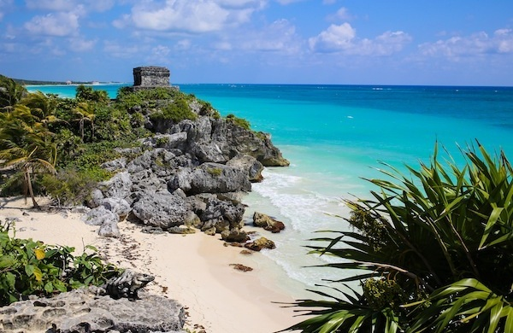

“The world is a book, and those who do not travel read only one page” ~Saint Augustine

overview
This lesson will help students to acquire new vocabulary in the vacation context to lead you to communicate with other people from around the world. Class is taught in Spanish.

Guiding question 1:
How the Imperfect past tense is used?
What are the verbs of emotion?

Lessons
_____ Family vacations
_____ Activities, skills, and abilities
_____ Describe a place and its climate
_____ Imperfect Past Tense
_____ Preterite vs. Imperfect

WEEK ONE- individual work
______1. Translate the beach vocabulary from your textbook avancemos 3 on pages pages 58- 59. due 9/12
______2. Practice more vocabulary by doing the exercises 1, 2, 3, on page 60 from your textbook. due 9/12
______3. Presentacion de Gramatica: Imperfect Tense on page 63. Do activities 6-9. due 9/13
______4. In paragraph describe a day at the beach that occured in the past using the forms of the preterite and imperfect tenses. due 9/13
_____ 5. Listen, on www.classzone.com to the narrative that describes Roberto’s family vacation. Pay attention to his activities. Write complete sentences. Do Actividad 6 - ¿Cómo pasaban las vacaciones? Page 64. You may partner with a classmate. due 9/16

Group work

_______1. With your peers describe the following scenes of the graphic novel about the meeting of Sandra and Santiago on the beach. Then complete the sentences with the verbs indicated imperfect. Page 67. due 9/19
______ 2. Prepare an interview to find out about a trip your peer has taken or would like to take with their family. Interview each other. (See handout for instructions) due 9/21
_______3. Create a brochure for a vacation to a Spanish speaking country incorporating the vocabulary from the chapter. Be prepared to answer clarifying/follow up questions from the teacher and/or your peers. due 9/23

Week two- Individual work Sept 26-Oct 7th
_____ 1. Presentación de Gramática: Preterite Vs. Imperfect. Do activity 12-16. Pag. 68. due 9/26
_____ 2. Mas practica: Use the past tense and the imperfect appropriate verb to explain what has happened during other activity in the process. Page. 69. due 9/26
_____ 3. Preterite and Imperfect: Twitter activity (see handout) due 9/27
_____ 4. Go to www.sparkenthusiasm.com to listen to the story, El árbol generoso. Due 9/30
_____ 5. Identify the preterite and imperfect tenses in the story, El árbol generoso and write them on your notebook. Be ready to share them with the teacher. Due 9/30
Group Work-
_____ 1. ¿Que hacían en la playa? Ask your classmate next to you
what her/ his relatives did when he or she came to the beach. Pg. 70. due 10/3
_____ 2. Write an email to your classmate to tell something of the excursion with your family. Includes elements of (imperfect) description of some activities that you and your family did and expressions (preterite) of emotion with the appropriate verb tense. Due 10/6
_____ 3. Exchange the emails with your peers in your table and compare. Look for preterite and imperfect! Due 10/7

Review of Unit. Oct 17th- 20th
*Pages 79-81 from your textbook avancemos 3*

Assessment- Due Friday Oct 21st
1) Answer in sentence form the following questions:
a) How the Imperfect past tense is used?
b) What are the verbs of emotion?
2) Vocabulary and grammar Imperfect past tense and Preterite vs. Imperfect test

