Spanish 2

Name:

Session:

essential understanding

Theme : Puerto Rico Filmamos en el mercado?

“ Puerto Rico, officially known as the Commonwealth of Puerto Rico (Estado Libre Asociado de Puerto Rico), is an unincorporated territory of the United States, located in the northeastern Caribbean, east of the Dominican Republic and west of both the U.S. Virgin Islands and the British Virgin Islands. Puerto Rico is only 100 miles long by 35 miles wide, making it the smallest island of the Greater Antilles. Puerto Rico (Spanish for "rich port") consists of an archipelago that includes the main island of Puerto Rico and several islands: Vieques, Culebra, Mona and numerous islets.” http://www.topuertorico.org
“

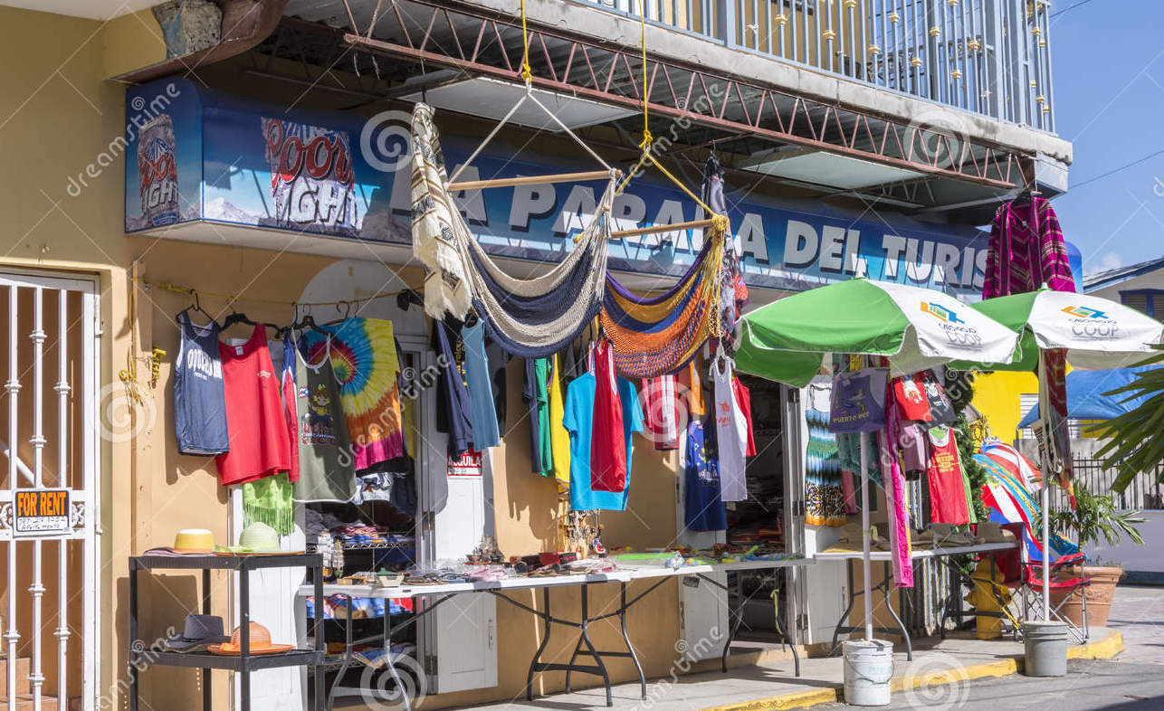
“ Puerto Rico is one of those places you can be as quiet or as crazy as you want, because there's so much nightlife. I have to take the craziness carefully”. Bruce Forsyth

Overview
In this unit you will see.
- Part 1- vocabulário: you will learn new words that will help you to describe activities and events, ask for and talk about ítems at a marketplace, and express yourself courteousely.
- Part 2- gramática: you will learn the verb hace + expression of time, irregular preterite verbs, preterite of –ir stem-chaging verbs.
- Part 3- Reading Comprehension. In this section, your will read real stories of events that happned in the Market of Puerto Rico and cultural related articles.
- Part 4- Listening Comprehension . Real life of events thru videos will be posted in the Google Classroom for you to practice your Spanish listening skills.
- Part 5- Research&Writing. In this session you will research subjects on the lesson topic and develop your writing skills.

- Guiding question 1:
What country does Puerto Rico belong to?
Lessons
_____ Presentation of the new vocabulary
_____ Gramatica - “ hace” + expression of time
_____ Gramática- irregular preterite verbs, preterite of ir-changing verbs
_____ Reading Comprehension
_____Reading Comprehension
_____Listening Comprehension
individual work
Part 1 – Vocabulary: All the individual work in part 1 is due April 7th
______1. Lesson Opening, pp 166-169. Participation of the lesson is not an option.
______2. Translate the blue words on pp 168- 169 into English.
_____ 3. Pratica de Vocabulario p. 170 , exercises 1, 2.
______ 4 .Vocabulario en contexto p 171 read the text and do the exercises 3, p.172.
______5. Exercise 4 Cuanto tiempo hace ? ” page 172.
_____6. Spanish Vocabulary Booklet . Use all the vocabulary learned in this lesson and make a booklet with pictures and the meaning/translation of each word. This activity has to be done in a Google slide show.
______7. Walk gallery day. This is the time when you will share your work(ex. booklet) with classmates. April 28th.
(Spring Break from 9th-17th )
Part 2–Grammar assignments. All the individual work in part 2 is due in April 21st
______8. Lesson opener: Grammar page 223 – Flash Cards ( Lesson)
______7. Exercise 6 “Máscaras” p 174.
______ 8. Exercise 7 ? Quién lo tuvo que hacer? p. 175.
_____ 9. Exercise 8 “ Hace much tiempo”, p.175.
______10. Exercises 10. La semana pasada p. 177.
______11.Grammar lesson open page 178- Stem-Changing Verbs –ir- ( Lesson)
______12. Exercise 11. En el Mercado, p.179.
______13 . Exercise 12 ! Hay mucha confusion! p. 179
______14. Exercise 13. ? Que passó? p. 180.
Part 3 – Reading Comprehension and related exercises assignments.
Do the following:
Read the attached texts in the goggle classroom and answer the questions.
______1 . Reading 1- “Abril: La Semana Santa.” April 7th
______2. Reading 2 – Activity 2: Mayo “ Cinco de Mayo May 5th
______3. Lectura cultural “El merengue. April 28th
______4. Read the test las artersanias and do the exercises, pp. 184,185. May 8th

Part 4 - Listening Comprehension
_____1. Video 1 – Listen to the “Telehistória” video #1 (Google Classroom) and in a Google doc write what understood.
_____2. Video 2- Listen to the Telehistoria video # 2 (Google Classroom) and make a list of all Spanish word you were able to understand.

Group work
Part 5- Research project
Do the following:
Topic: Puerto Rico: ¡Vamos de compras!
Task: What to do.
______1.You and your classmates will work in groups of three to learn more about Spanish-speaking countries and some of the shopping experiences you could have there. Each person in your group will find information about a different country and share their findings with the group.

Before starting your research, you and the other members of your group will talk about your shopping experiences and attitudes. You will share, for example, about whether you like to shop or not, what you like to buy, and where you have bought things in the last two weeks. You should also say what you want to buy if you go shopping in another country.

Next, you need to decide as a group who will research shopping in each country. Your choices are Perú, Puerto Rico, and Panamá, all of which offer a wide array of choices for the consumer. Each student will learn about a country, take notes, and then present to the group in Spanish. You will find that each country is quite different, and that each offers a variety of things to buy and places to buy them. Your group will vote, finally, on where they would prefer to go shopping. A copy of the form will be provided to each group. You will have more detailed information about the project in the Google classroom. Due April 20th

______2. With your partner create a movie of 5 minutes with all information acquired from the research project. The idea is to create a story of shopping in the market of Puerto Rico or any other topic there( feel free) . The conversation must to be in Spanish. The other option is to write the caption lock in Spanish bellow the conversations. Due May 5th
Assessment
_____1. Online vocabulary quiz #1, April 7th ,
_____2. Online Grammar quiz # 2, April 14th
_____3. Online Grammar quiz # 3, April 21ts
_____3. Read Comprehension test, May 5th^{th}

