Spanish 1

Name:

Session:

essential understanding

Theme : España Que hacemos esta noche?
“ Spain is synonymous with fun, high spirits, great weather, and above all, a fantastic nightlife. You'll soon find that specially in large cities like Madrid, Barcelona, Valencia, Bilbao and Granada, and in areas such as the island of Ibiza, the Costa del Sol and Benidorm to name just a few, there's a whole host of restaurants, bars, concert venues, pubs and clubs that guarantee you a night to remember, and which will go on until dawn and beyond. Going out for tapas in a string of different bars, getting to know the open and friendly temperament of the Spaniards, dancing to the beat of top international DJs, partying on in an after-hours club... there are numerous different options to choose from, which is what makes Spain's nightlife so incredibly special. Come and discover them” (http://www.spain.info/en_US/reportajes/Espana_una_fiesta_nocturna_continua.html )
“

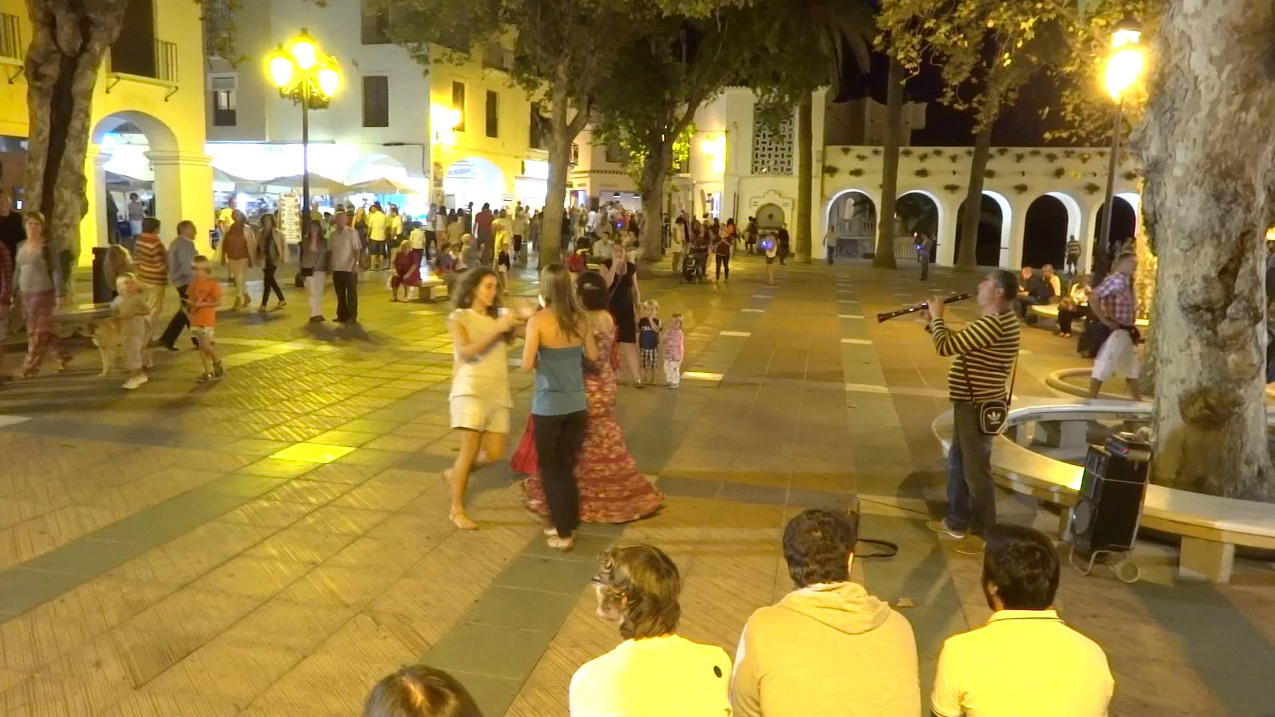
“ In Spain, the dead are more alive than the dead of any other country in the world”. Federico Garcia Lorca

Overview
In this unit you will see.
- Part 1- vocabulário: you will learn new words that will help you to describe places and events in the town, talk about types of transportation, say what you are going to do, and order from a menu.
- Part 2- gramática: you will learn verb VER, IR, a + infinitive, stem changing verbs o ---ue, stem-changing verbs e.
- Part 3- Reading Comprehension. In this section, your will read real stories of events that happened in Spain and cultural related articles.
- Part 4- Listening Comprehension . Real life events thru videos will be posted for you to practice your Spanish listening skills.
- Part 5- Research&Writing. In this session you will research subjects on the lesson topic to develop your writing skills.

- Guiding question 1:
What do you know about Spain? Give some examples of things or events you have heard from there.
Lessons
_____ Presentation of the new vocabulary
_____ Gramatica - Verb Ver, ir + infinitive
_____ Gramática- Stem-changing verbs
_____ Reading Comprehension
_____Reading Comprehension
_____Listening Comprehension
individual work
Part 1 – Vocabulary: All the individual work in part 1 is due April 7th
______1. Lesson Opener, pp 216 -217-Presentation of the vocabulary.(Not an option)
______2. Translate the blue words on pp 218-219 into English.
_____ 3. Pratica de Vocabulario p 220 , exercises 1, 2.
______ 4 .Vocabulario en contexto p 221 read the text and do the exercises 3, p.222.
______5. Exercise 4 Qué vas a comer? ” page 168.
_____6. Spanish Vocabulary Booklet . Use all the vocabulary learned in this lesson and make a booklet with pictures and the meaning/translation of each word. This activity has to be done in a Google slide show.
______7. Walk gallery day. This is the time when you will share your work(ex. booklet) with classmates. April 28th.
Spring Break from 9th-17th
Part 2–Grammar assignments. All the individual work in part 2 is due on April 21st
______8. Lesson opener: Grammar page 223 – Flash Cards ( Lesson)
______7. Exercise 5 “Un concierto de música rock” p 224.
______ 8. Exercise 6 ? Las atividades en el centro? page 224.
_____ 9. Exercise 7 “Todos tienen excusas” page 225.
______10. Exercises 8? Vamos ir de compras? page 225.
______11.Grammar lesson open page 228- Stem-Changing Verbs e-I ( Lesson)
______12. Exercise 10 ? Que encuentras? Page 227
______13 . Exercise 11 ? Qué pidem? page 229
______14. Exercise 12 “ ? Quién sirve la comida? page 229.
______14. Exercise 14 “ Qué pides del menu? ” page 230.
Part 3 – Reading Comprehension and related exercises assignments.
Do the following:
Read the attached texts in the goggle classroom and answer the questions.
______1 . Reading 1- “Abril: La Semana Santa.” April 7th
______2. Reading 2 – Activity 2: Mayo “ Cinco de Mayo” May 4th
______3. Lectura cultural “ El fin de semana en España y Chile. April 28th.

Part 4 - Listening Comprehension
_____1. Video 1 – Listen to the “Telehistória” video #1 (Google Classroom) and in a Google doc write what is understood.
_____2. Video 2- Listen to the Telehistoria video # 2 (Google Classroom) and make a list of all Spanish words you were able to understand.

Group work
Part 5- Research project – Group maximum of 4-5 students.
Do the following:
Topic: España: En el centro
Task: What to do.
______1.In order to raise funds for a class trip, your Spanish class has decided to set up an in-school store that sells items from Spain. If the sales of these items are popular, you plan to expand your inventory to include other items from around the Spanish-speaking world. So, In order to open your store, you’ll need to buy the items you plan to resell. But first, you need to identify what goods you think will appeal to your fellow students. Once you do that, you will research one of four different categories of items—books, music, foods, and handicrafts—and make a presentation recommending five items from that category you think would be the most popular at your school. At the end of all the presentations, the group will compile a list of five recommended items for each of the four categories and share it with the class. Read more about the project in the Google Classroom. I also will provide a hard copy, for each group, of the form to do the research and fill. Due April 20th

______2. With your partner create a movie of 5 minutes with all information acquired from the research project. The idea is to create a story with “ Shopping in Spain” the conversation must to be in Spanish. The other option is to write the caption lock in bellow the conversations. Due May 5th
Assessment
_____1. Online vocabulary quiz #1, April 7th ,
_____2. Online Grammar quiz # 2, April 14th
_____3. Online Grammar quiz # 3, April 21ts
_____3. Read Comprehension test, May 5th^{th}

