Honors Biology: Cell Biology
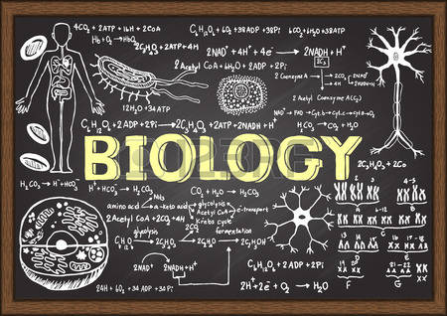

Essential Understanding: The fundamental processes of plants and animals depend on a variety of chemical reactions that occur in specialized areas of an organism’s cell.

“Biology will relate every human gene to the genes of other animals and bacteria, to this great chain of being” -Walter Gilbert

Overview
This unit is designed to help students become familiar with the study of cells and the tools that are used for this. Students will be able to know the differences and similarities between Eukaryotic and Prokaryotic cells. This unit will require critical thinking, understanding the concept of studying cells, and analysis of problems.

Guiding question 2: How are the cell’s structures connected to its function and process?

Individual work

_____ Participate in the lesson on the very graphic cell. Record the information.
_____Read: Prentice Hall Science Explorer: Cells & Heredity
_____ Ch 2 Section Assessments (11/15)
_____ Ch 3 Section Assessments (12/2)
_____ Ch 4 Section Assessments (12/16)
_____ Ch 5 Section Assessments (01/10)

_____Reflect on the answer to Guiding Question 2. Update your mind map with the group presentation. (01/13)
_____Make vocabulary cards for the vocabulary in your Vocabulary List.
_____Understanding Scientific Paper in Depth (12/6)

Group work/ Lab Work
End of the Chapter Section Presentations: After every chapter, students will work in groups of 2-3 to create a presentation that will give an overview of the chapter. Presentations can include, but are not limited to, PowerPoint, Prezi, poster board, drawing, etc.

Labs will be done in groups of 4 or 5.
Lab Handouts: There will be a pre-lab for students to complete before the lab experiment, during the lab the students will gather the necessary data to complete the lab and answer the questions associated with the topic. After the necessary data is collected students will work on completing their lab notebook.

Lab Notebook: Every student is required to keep a lab notebook. The lab notebook will be each student’s personal “copy”. You will receive specific instructions on the lab notebook requirements.

This notebook will be graded on proper usage and completeness. The lab notebook will be checked once a unit on the day of the assessment.

Formal Laboratory Report: Each quarter students will put together a formally written laboratory report. This laboratory report is done individually (plagiarisms is not allowed). The report must be typed and include; Title, Purpose, Procedure, Materials, Observations, Data, Results, Conclusion and Citations.

How do I put it altogether?
Students will be completing a group project for the cell biology section. As a group the students are to design a cell: Eukaryotic and Prokaryotic cell. They must design a model of the cell with names of each organelle, function, and definition (written in the students own words).
_____Take the vocabulary test you must show mastery to be complete. Students may use previously assigned vocabulary card assignment. (12/20)
_____Review for your self-assessment.

Assessment
- Testing your Knowledge
- Assessment will include all material covered in class (paper assessment) (12/20)
- Research poster: Human Genetic Disorder (12/16)
- Cell Cycle Poster Board:
  - Identify each cell cycle phase
  - Give a visual representation of the cycle

Extension
Research a mammal or living organism by doing an in-depth study or analysis of its four needs to stay alive. (01/06)

Vocabulary List
Ch 2
Ch 2.1 photosynthesis, autotroph, heterotroph, pigment, chlorophyll, stomata
Ch 2.2 respiration, fermentation
Ch 2.3 cell cycle, interphase, replication, mitosis, chromosomes, cytokinesis
Ch 2.4 cancer, mutation, tumor, chemotherapy
Ch 3
Ch 3.1 heredity, trait, genetics, fertilization, purebreed, gene, alleles, dominant alleles, recessive alleles, hybrid
Ch 3.2 probability, Punnett square, phenotype, genotype, homozygous, heterozygous, codominance
Ch 3.3 meiosis
Ch 3.4 mRNA, tRNA
Ch 4
Ch 4.1 multiple alleles, sex chromosomes, sex-linked gene, carrier
Ch 4.2 genetic disorder, pedigree, karyoptype
Ch 4.3 selective breeding, inbreeding, hybridization, clone, genetic engineering, gene therapy, genome
Ch 5
Ch 5.1 species, fossil, adaptation, evolution, scientific theory, natural selection, variation
Ch 5.2 homologous structures, branching tree
Ch 5.3 petrified fossil, mold, cast, relative dating, radioactive dating, radioactive element, half-life, fossil record, extinct, gradualism, punctuated equilibria

