Geometry

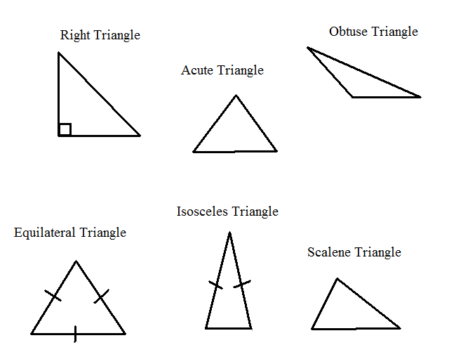

[If a man's wit be wandering, let him study the mathematics.](http://www.brainyquote.com/quotes/quotes/f/francisbac101079.html)

[**Francis Bacon**](http://www.brainyquote.com/quotes/authors/f/francis_bacon.html)

**Essential understanding**

Geometry brings math to life with many real-life applications. Examples of mathematics in sports, engineering, and carpentry will be shown throughout this unit. Three key aspects of geometry that will be emphasized are measuring, reasoning, and applying geometrical ideas. As you explore the applications presented in this quarter, try to make connections between mathematics and the world around you.

**Overview**

**Lessons** will be given in class. You will have multiple mini lessons throughout the week. If you are struggling with a concept, it is your responsibility to review the lessons and ask questions. I will answer any questions you have during the lesson but after that we will follow the “three before me” principle. You must ask three of your peers before you ask me for help.

**Math Journal:** I encourage use of your geometry journal during lessons and work time. I advise you to use your journal to take notes during lessons and to work on assignments. Make sure it is neat and organized. Any and all important information from the lessons should be kept in this journal. You will be able to use your journals for formative assessments (quizzes).

**General Guidelines:**

**Problem Sets –** 40% of your grade is based on completing each homework assignment. **Homework Assignments Are Recommended Problems For Learning (and are required to pass this class!!).** It is recommended that you do the assignments or similar math problems in order for you to understand and retain the concepts. Use the work period to ask for help from your peers and teacher. **You will submit pictures of your assignments through Google Classroom by Sunday night (11:59pm) each week.**

**Quizzes/Assessments –** Quizzes/Assessments make up 30% of your grade and you must complete each quiz/assessment prior or on the date it is scheduled. **Remember: you can always use your notebook on quizzes and exams.** You must make at least 70% to “pass” the quiz/assessment. If you do not pass a quiz, you may retest using a similar exam during my tutoring hours. You may also correct quizzes for half the remaining credit.

**Final Assessment** – The final will make up 30% of your grade. You will not be able to make up the final exam. That is why it is important that you record the notes from the lessons and you do the suggested homework assignments. Practice the concepts in order to master them. **Your final project is also a part of your final assessment grade.**

**Big Ideas**

1. Parallel and Perpendicular Lines
2. Classifying Triangles
3. Properties and theorems on triangles

**Vocabulary**

1. Equilateral
2. Acute
3. Obtuse
4. Base
5. Vertex
6. Adjacent sides
7. Hypotenuse

**Individual work**

**Guiding question 3:**

**How can properties of parallel lines help you predict the paths of boats sailing into the wind?**

1. ***3.1 Lines and Angles:***

_____ p.132 #’s 1 through 31 (odds)

_____ Mixed Review p.134 #’s 47 through 61 (odds)

1. ***3.2 Proof and Perpendicular Lines:***

_____ p.138 #’s 1 through 19 (odds)

_____ Mixed Review p.141 #’s 29 through 35 (odds)

1. ***3.3 Parallel Lines and Transversal:***

_____ p.146 #’s 1 through 27 (odds)

_____ Mixed Review p.149 #’s 33 through 43 (odds)

**_____ QUIZ FOR LESSONS 3.1 – 3.3 (November 8th)**

1. ***3.4 Proving Lines Are Parallel:***

_____ p.153 #’s 1 through 27 (odds)

_____ Mixed Review p.156 #’s 41 through 47 (odds)

1. ***3.5 Using Properties of Parallel Lines:***

_____ p.160 #’s 1 through 23 (odds)

_____ Mixed Review p.163 #’s 43 through 51 (odds)

1. ***3.6 Parallel Lines in the Coordinate Plane:***

_____ p.168 #’s 1 through 41 (odds)

_____ Mixed Review p.171 #’s 59 through 73 (odds)

1. ***3.7 Perpendicular Lines in the Coordinate Plane:***

_____ p.175 #’s 1 through 35 (odds)

_____ Mixed Review p.178 #’s 55 through 61 (odds)

1. **CHAPTER 3 ASSESSMENT (November 28th)**

**Guiding question 4:**

**How does a cable-stayed bridge work?**

1. ***4.1 Triangles and Angles:***

_____ p.198 #’s 2 through 38 (evens)

_____ Mixed Review: p.201 #’s 52 through 59

1. ***4.2 Congruence and Triangles:***

_____ p.205 #’s 4 through 28 (evens)

_____ Mixed Review: p. 209 #’s 41 through 57

1. ***4.3 Proving Triangles are Congruent:***

_____ p.216 #’s 4 through 22 (evens)

_____ Mixed Review: p.219 #’s 39 through 43

1. ***4.4 Proving Triangles are Congruent Part 2:***

_____ p.223 #’s 2 through 20 (evens)

_____ Mixed Review: p.32 #’s 61 through 79 (odds)

1. ***4.5 Using Congruent Triangles:***

_____ p.232 #’s 4 through 18 (evens)

_____Mixed Review: p.235 #’s 25 through 36

**_____ QUIZ FOR LESSONS 4.1 – 4.5 (December 13th)**

1. ***4.6 Isosceles, Equilateral, and Right Triangles:***

_____ p.239 #’s 2 through 24 (evens)

_____ Mixed Review: p.242 #’s 45 through 55

1. ***4.7 Triangles and Coordinate Proofs:***

_____ p.246 #’s 6 through 26 (evens)

_____ Mixed Review: p.250 #’s 35 through 40

**Guiding question 5:**

**How can a goalkeeper best defend the goal?**

1. ***5.1 Perpendiculars and Bisectors:***

_____ p.267 #’s 4 through 26 (evens)

_____ Mixed Review p.271 #’s 41 through 52 (all)

1. ***5.2 Bisectors of a Triangle:***

_____ p.275 #’s 4 through 22 (evens)

_____ Mixed Review p.278 #’s 32 through 40

1. ***5.3 Medians and Altitudes of a Triangle:***

_____ p.282 #’s 4 through 26 (evens)

**_____ QUIZ FOR LESSONS 4.6 – 5.3 (January 10th)**

1. ***5.4 Midsegment Theorem (Jan. 14th):***

_____ p.290 #’s 4 through 28 (evens)

_____ Mixed Review p.293 #’s 39 through 49

1. ***5.5 Inequalities in One Triangle (Jan. 19th):***

_____ p.298 #’s 6 through 26 (evens)

_____ Mixed Review p.301 #’s 39 through 49

**assessment January 17th:**

_____ Chapter 3, 4 and 5 Final

_____ Final Project