Name:

…………………………………………………………………………………………………………………….

essential understanding
Fashion design is influenced by cultural and social latitudes, and has varied over time and place. Fashion designers work in a number of ways in designing clothing and accessories. Some work alone or as part of a team. They attempt to satisfy consumer desire for aesthetically designed clothing; and, because of the time required to bring a garment onto the market, must at times anticipate changing consumer tastes. Some designers in fact have a reputation which enables them to set fashion trends.

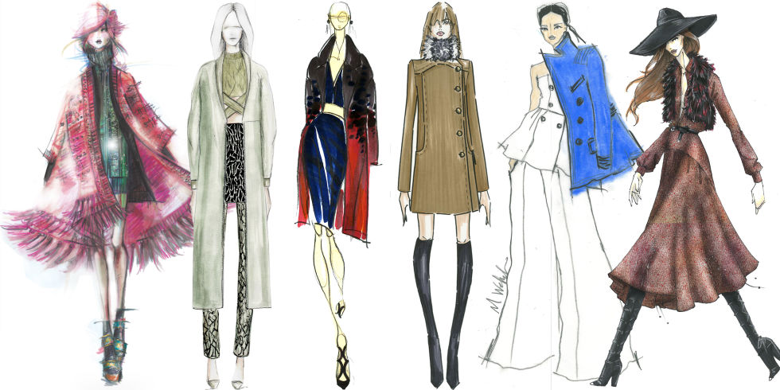

“Everyday is a fashion show and the world is the runway” ~COCO CHANEL

Overview
This course introduces students to the creative process of fashion design. Students will begin with color theory and will move to fabric research, and clothing construction. They will develop a self portrait and students will work with shapes, lines, colors, and patters to create a fun and interesting self portrait. A variety clothing styles will be designed, including but not limited to: men’s, women’s, and teenage designs and accessories. Students will use a variety of art materials including pencils, markers, and acrylic paint, sketchbook. Students may be expected to purchase fabrics or other materials at a minimal cost.

Guiding question 1:

What difficulties arose when making the embroidered self portrait?
What could you have done differently?

lessons
____Color wheel
____Fabric and materials
____Textile design
____ Fashion jewelry

individual work

_____ 1. Create a “clothing color wheel” using magazine pictures, create an accurate color wheel made with pieces of clothing. Be creative! Your color wheel must be your own creation, in the shape of a wheel and must include at least the primary and secondary colors. Due 11/2
______2. Mixing Color Experiment front side of page (use primary and neutral colors first) Then, write down each step you took to achieve the final color. Due 11/9
______3. Create an embroidered self portrait using had stitching (see handout for complete instructions) due 12/7

group work

______1. In a group of 4 people design a clothing line (male or female) and design 5 outfits for a fashion show. Make sure include garments for Spring, Summer, and Fall. You must also write a 1 page summary as to how these outfits represent each season. Be sure to research current design trends to keep this fashion up today. Due 1/4
______ 2. In group of 4 people create a Fashion Retail store design that will be related to your clothing line. Please read the following guidelines to help you with the project. Due 1/18

individual work
_____1. Design an Inspiration Board for trending accesories using magazine pictures. Due 2/8
_____ 2. Make your own stylish fashion jewelry using a range of beads, wire and chain and guided by jewelry expert Ms. Ramirez. 2/15

Assessment- due 2/22
1. Recycle Fashion Project (Instructions to be announce)

