Photography

Name:

Session:

essential understanding
Getting to Know the camera
The Basics
"The camera is, in its most simplified terms, a box that allows light to enter and strike a light-sensitive surface. This surface is either a frame of film or a digital sensor. Cameras can accomplish this task in the most simple way—a pinhole camera, for instance. Pinhole cameras may have only one moving part, or none. Or, the camera can have dozens of moving parts like the modern film or digital single-lens reflex (SLR or DSLR) camera. In this study guide, we will discuss the modern cameras popular with today’s photographers. We are going to talk about cameras in general terms, so please know that I am aware of dozens of different ways in which different cameras make images. For simplicity’s sake, we will keep it simple!" Source https://www.bhphotovideo.com/explora/photography/tips-and-solutions/how-your-digital-camera-works

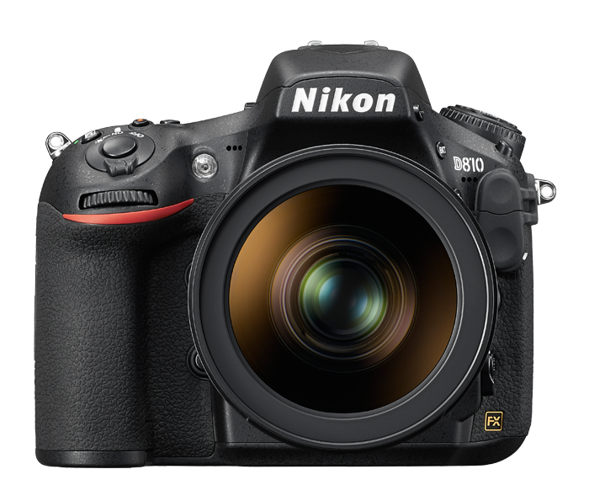

" Working in front of the camera keeps me alive." Chow Yun-Fat

Overview
In this unit you will see.
- The basic features of a professional camera
- Flash on and off camera.
- Types of lens
- How to use differents modes in camera
- Nearby field trips
- Warm ups
- Reflections
- Hands on Projects
Guiding question 1:
What does is “manual mode” in a camera?
Lessons
____Introduction
____Getting to know the camera
____Tutorial
____Basic Photography and playback
____Focus
____Release Mode
____ISO Sensitivity
____Exposure
____White Balance
____Flash Photography
____Black & white photography /Gray Scale.
____Street photography
____History of the camera
individual work
Getting to know the camera. All the individual assignments are posted in the - Google Classroom. Due on May 12th.
______1. Activity a- Introduction.
______2. Activity b- Tutorial
______3. Actvity c- Focus
______4. Activity d- Release Modes
______5. Activity e- ISO Sensitivity
______6. Activity f- Exposure
______7. Activity g -White Balance
______8. Activity h- Flash Photography

______9. Reflection # 1,# 2, # 3 , # 4 # 5 # 6 . In a Google doc you will write your reflection up on the topic lesson of this unit. Choose how you want to present your reflection.
a. _________ a painting
b.__________ a drawing
c. __________a collage
d. __________ a paragraph
Group work
Choose three of the following: Due day May 25th.
Hands on Project:
Task: What to do.
______1. Pick-A-Something- The upside of this project is that it, once again, gets you to start seeing ordinary things in a different way – taking a snapshot looking down at everyone’s shoes is going to start to get boring, so it forces you to start thinking creatively. The downside of this project is that people are going to start giving you weird looks for crawling around on the ground taking pictures of shoes while everyone else is enjoying walking, lunching, chatting, or playing any sport. See the example below:

______2. A-Z project. You can pick a place and try to get a picture of objects that start with or represent each letter of the alphabet (for instance, it might be easy to take a photo of the grass for G, but Q is going to be harder, maybe a picture of a kid running around could be Quick, or a picture of a completely still pond could be Quiet). You can also try this with numbers, too – take a photo of one acorn on the ground, two ducks by a pond, three trees grouped together, etc. See the picture below.
The other interpretation of this project is to take pictures of things that look like the letters A-Z. Take a look at the photo above, it’s actually a chain to a porch swing, but the one piece looks like a letter S. Once you start this project you’ll start looking at ordinary things – buildings, cloud formations, playground equipment, etc. – in a completely different way, giving you a new perspective on things to photograph. This project can also be done with numbers, too. See the example above.
________3. Go Mono
For this assignment you will need to do all your photos in black-and-white. The goal is to get better at converting photos to black and white. After doing this you will start to see things differently. This project will help you to figure out what photos would look better in mono, and which ones wouldn’t. See the picture below.
______4 Photo walks- Street Photography
Photo walks often include groups of people walking through cities together, all capturing images of the same landmarks from their own point of view. You need to walk out the door once a week and search for local parks, abandoned buildings (careful with this one: it can be frowned upon or even illegal to poke around some abandoned buildings), downtown and other small towns near you. See the pic below.
______

_5. Timeline of cameras: In your group make a timeline of the evolution of the camera. Use cardboard or scroll format. See the example:
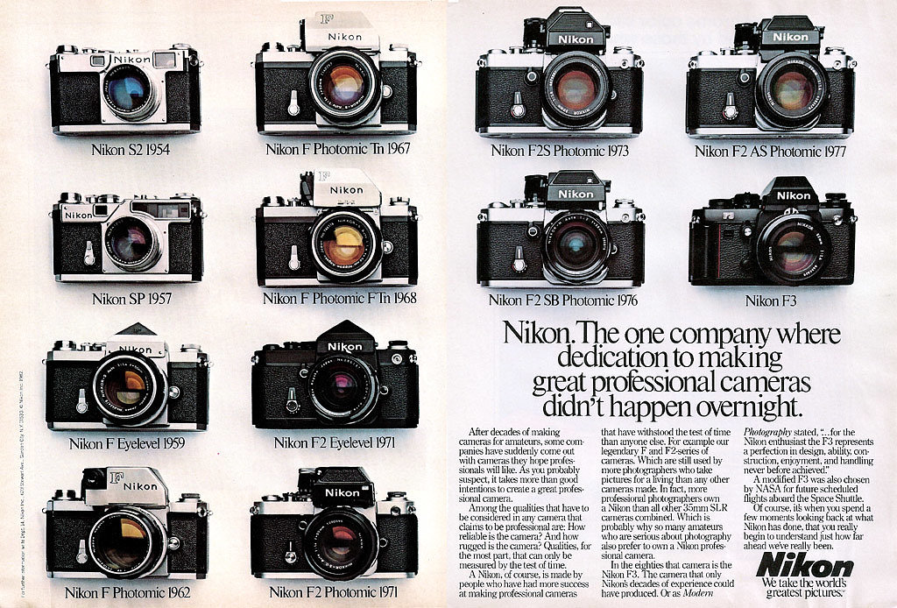
Assessment
All groups need to present your group projects and give details of each work. All students must participate of the presentations and provide pictures of your own work done indoors or outdoor.
_____1. Project # 1 Presentation, May 10th
_____2. Project # 2 Presentation, May31st

_____3. Timeline project, May 24th

