Biology: DNA as the
Genetic Material

Essential Understanding: DNA is the genetic material that provides instructions for building and maintaining your body.

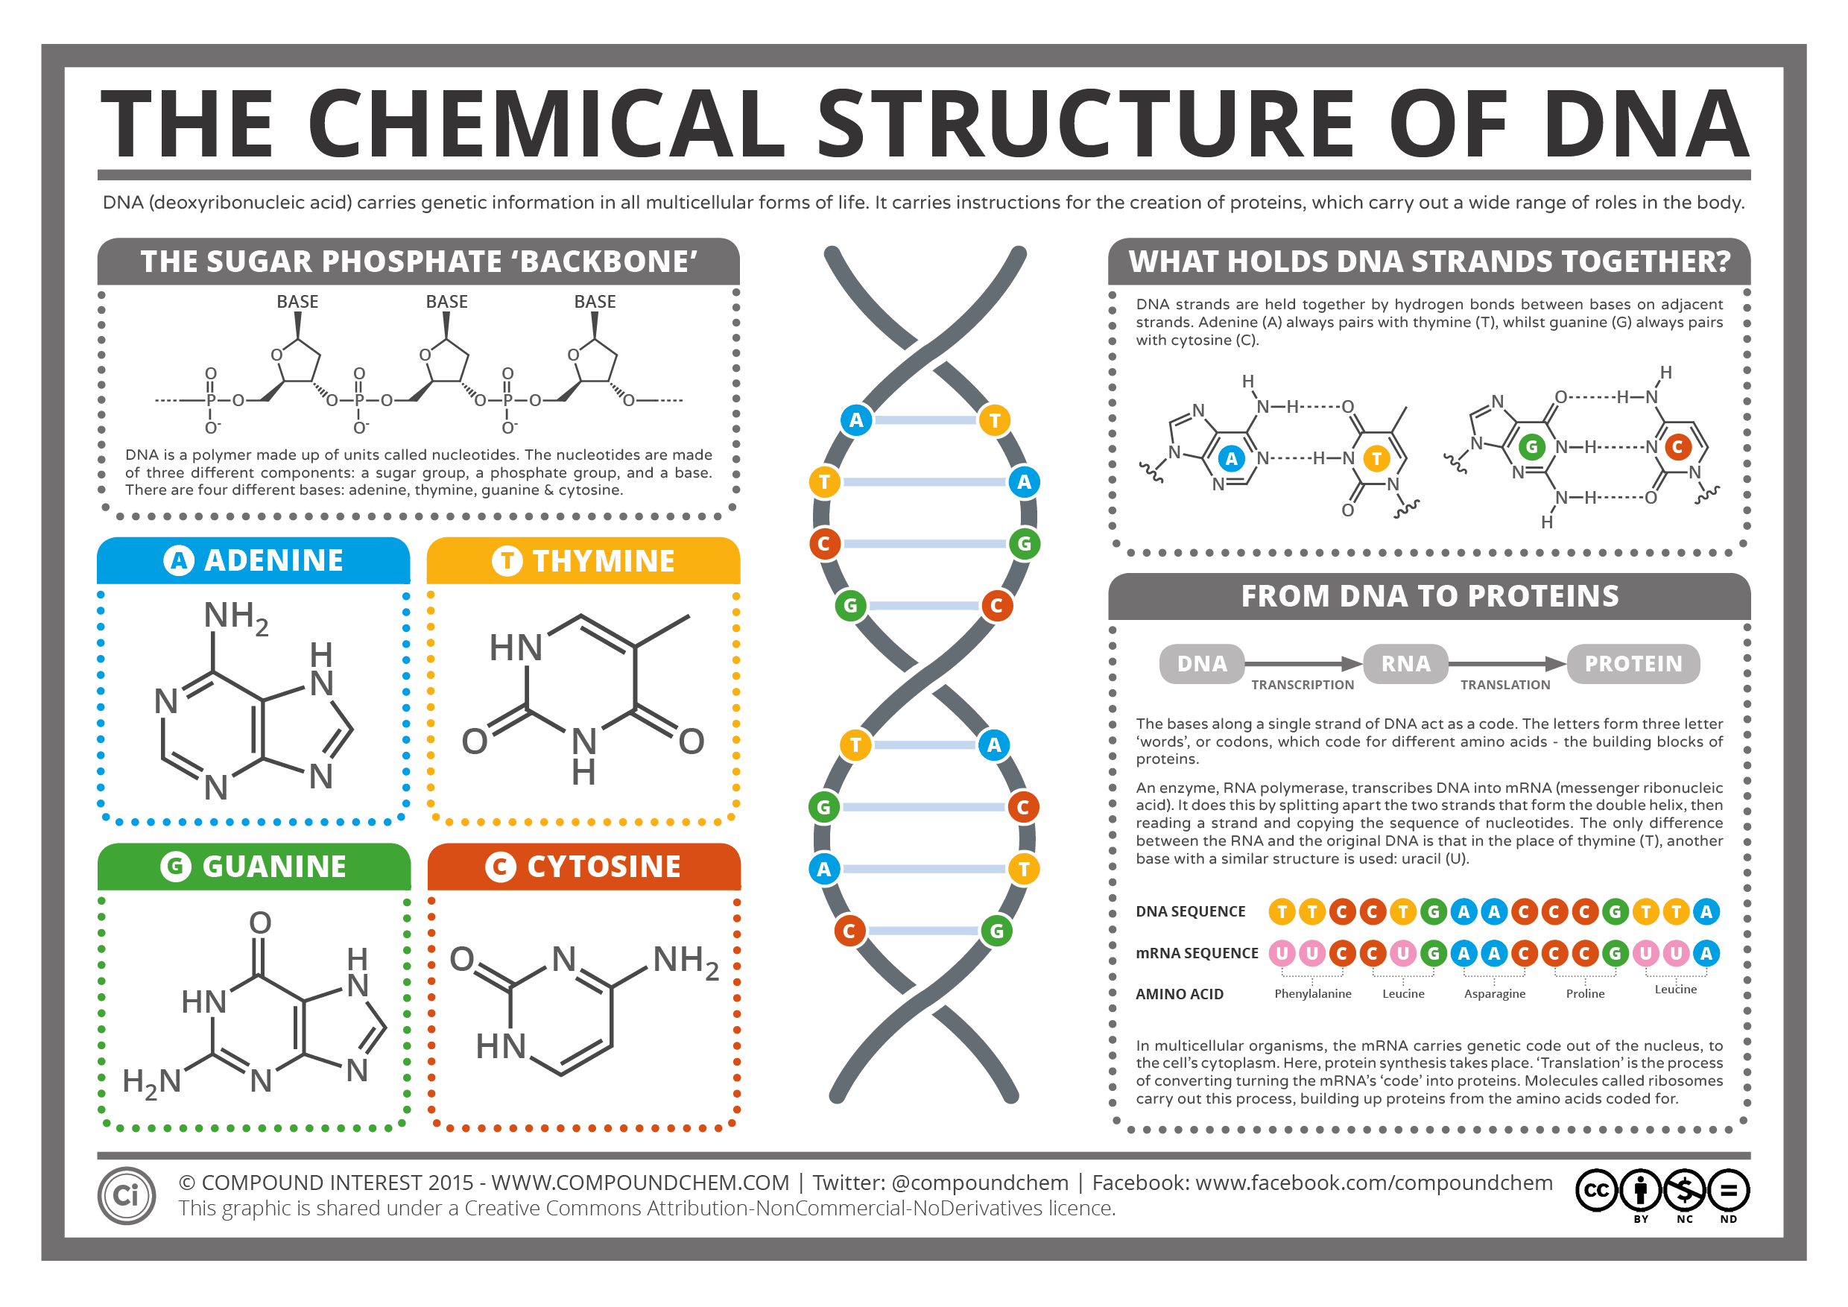

“If, for example, all the codons are triplets, then in addition to the correct reading of the message, there are two incorrect readings which we shall obtain if we do not start the grouping into sets of three at the right place.” -Francis Crick

Overview
This unit is designed to help students become familiar with DNA. Students will learn how this polymer is made from only four monomers, which serves as the genetic material for all living organisms. We will explore the discovery, structure, and synthesis of DNA.
Guiding question 1: How does a gene in your DNA provide instructions for building a protein?

Individual work
_____ Read Study Guide (01/30)

_____ Participate in the lesson “DNA as Genetic Material”
_____ Nucleic Acid (01/30)
_____ Discovery of DNA (02/02)
_____ DNA replication (02/06)
_____ Central Dogma/Genetic code (02/20)
_____ Transcription & Translation (02/16)
_____Reflect on the answer to Guiding Question 1 (02/16)
_____Make vocabulary cards for the vocabulary in your Vocabulary List (as needed, vocabulary card will not be allowed on quizzes or tests)
Group work/ Lab Work
Labs will be done in groups of 4 or 5.
Lab Handouts: There will be a pre-lab for students to complete before the lab experiment, during the lab the students will gather the necessary data to complete the lab and answer the questions associated with the topic. After the necessary data is collected students will work on completing their lab notebook.

Lab Notebook: Every student is required to keep a lab notebook. The lab notebook will be each student’s personal “copy”. You will receive specific instructions on the lab notebook requirements.

This notebook will be graded on proper usage and completeness. The lab notebook will be checked once a unit on the day of the assessment.

Formal Laboratory Report: Each quarter students will put together a formally written laboratory report. This laboratory report is done individually (plagiarisms is not allowed). The report must be typed and include; Title, Purpose, Procedure, Materials, Observations, Data, Results, Conclusion and Citations.

How do I put it altogether?
Students will be completing a group project for the DNA as Genetic Material section. As a group the students are to design a model for double helix DNA. They must include every part of the double helix. The project can not be a PowerPoint, Prezzi, or slide. Your project should include a poster board explaining each part that makes up DNA & its function. You will have time during class to work on this, but may require work outside of class (02/23)
_____Take the vocabulary test you must show mastery to be complete. Students may use previously assigned vocabulary card assignment. (02/16)
_____Review for your self-assessment.

Assessment
- Testing your Knowledge - “DNA as Genetic Material” (02/23)
Assessment will include all material covered in class (paper assessment)

